Response of surface temperature to afforestation in the Kubuqi Desert, Inner Mongolia

Liming Wang^{1,3,4}, Xuhui Lee^{2,3*}, Natalie Schultz³, Shiping Chen⁵, Zhongwang Wei^{2,3}, Congsheng Fu^{2,3}, Yunqiu Gao^{2,3}, Yanzheng Yang^{1,4}, Guanghui Lin^{1*,4}

¹Ministry of Education Key Laboratory for Earth System Modeling, Department of Earth System Science, Tsinghua University, Beijing 100084, China;
²Yale-NUIST Center on Atmospheric Environment, Nanjing University of Information Science and Technology, Nanjing 210044, China
³School of Forestry and Environmental Studies, Yale University, New Haven, Connecticut 06511, USA.
⁴Division of Ocean Science and Technology, Graduate School at Shenzhen, Tsinghua University, Shenzhen 518055, China
⁵State Key Laboratory for Vegetation Ecology, Institute of Botany, Chinese Academy of Sciences, Beijing, 100093, China

Correspondence to:
Guanghui Lin: lingh@tsinghua.edu.cn; Xuhui Lee: xuhui.lee@yale.edu

Key points:
- Plantation forest is cooler in the daytime and mostly warmer at night than an adjacent shrub land in Inner Mongolia, China.
- Energy balance closure is an important condition for partitioning of biophysical effects of land use change.
- Biophysical contributions from the surface temperature decomposition metric theory are an order of magnitude greater than the related terms from the intrinsic biophysical mechanism theory.

Abstract
In this study, micrometeorological observations in a shrub ecosystem and an adjacent poplar plantation forest ecosystem in the Kubuqi Desert, Inner Mongolia, China, are used to evaluate the theory of intrinsic biophysical mechanism (IBPM) and to investigate the biophysical effects of afforestation. Results indicate that after forcing energy balance closure to the observed fluxes, the IBPM theory agrees very well with the observed temporal variations in the surface temperature and with the observed temperature difference between the paired sites at the half-hourly time scale. Afforestation activity in this dryland landscape has a cooling effect (−0.5 ± 0.2 K) in the daytime in all the seasons and a warming effect (0.2 ± 0.1 K) in the nighttime during the winter, spring and autumn, but a cooling effect (−1.0 ± 0.3 K) in the summer at night. These temperature changes are decomposed into contributions from changes in surface albedo, surface roughness, Bowen ratio and ground heat flux. Comparison is made between the IBPM theory and the theory of the decomposition of surface temperature metric (DTM).

Keywords:
Land cover change; Surface temperature; Biophysical forcings; Temperature decomposition metrics; Energy balance closure

1. Introduction
The influence of forest management on the climate system can be evaluated in terms of their carbon sequestration potential or biogeochemical effect [Hudiburg et al., 2011; Holtsmark, 2012] and biophysical forcings [Bonan, 2008; Davin and de Noblet-Ducoudre, 2010; Bright et al., 2014; Mahmood et al., 2014]. The biophysical contributions to the climate system include the exchanges of energy, water, and momentum between the earth’s surface and the lower atmosphere. Unlike the biogeochemical effect, the biophysical processes are dependent on regional climate conditions. For example, albedo change dominates the biophysical effect of deforestation in the boreal zone, especially in the winter because of snow cover and a land albedo-sea ice feedback [Bonan et al., 1992; Davin and de Noblet-Ducoudre, 2010]. In tropical climate, the role of albedo change is minor, and evapotranspiration change plays a major role in determining the overall deforestation climatic impact [Bala et al., 2007]. Changes in surface roughness appear to be more important in humid climates than in dry climates, because of its influence on sensible heat dissipation and on the latent heat flux [Lee et al., 2011; Bright et al., 2017; Rigden and Li, 2017; Burakowski et al., 2018]. Because of this regional context, the same land management regime will have very different climate consequences in different climate zones. The ability to partition the overall biophysical effect to these component contributions constitutes an integral part of climatic evaluation of land management.

Currently there are two main theories for isolating the contributions to changes in surface temperature from individual biophysical factors of land use change. The first theory, termed the direct decomposed temperature metric (DTM) theory, was first proposed by Juang et al. [2007] and later refined by Luyssaert et al. [2014]. The DTM theory attributes changes in the surface temperature due to differences in surface albedo, incoming radiation, ground heat flux, and sensible and latent heat flux between two land use classes. The temperature perturbation is a direct consequence of the surface energy balance and linearization of the Stephan-Boltzmann expression for the surface outgoing longwave radiation.

The second theory, termed the intrinsic biophysical mechanism (IBPM) theory, was first proposed by Lee et al. [2011] to investigate the local climate effect of deforestation and later modified by Zhao et al. [2014] to quantify surface temperature responses to urbanization. According to this theory, changes in the surface temperature in response to land use changes are consequences of the local longwave radiative feedback at the surface and energy redistribution brought by changes to the aerodynamic resistance and surface evaporation.

These theories can be used for diagnostic or prognostic calculations. In a diagnostic application, all variables needed for the partitioning calculation are either provided by field measurements or as model outputs; no parameterizations are involved. Zhao et al. [2014] and Chen and Dirmeyer [2016] provided two examples of diagnostic application in the investigation of urban heat islands and the biophysical effect of land cover change, respectively. In a prognostic application, the resistance to heat diffusion in the IBPM theory is predicted with a set of parameterization equations. For example, Lee et al. [2011] calculated the total heat diffusion resistance by combining a standard Monin-Obukhov formulation for the aerodynamic resistance with a formulation for the radiometric resistance. In a study on the biophysical effects of alternative forest management in Norway, Bright et al. [2014] calculated the heat resistance using a formulation for neutral conditions.

Chen and Dirmeyer [2016] have compared the DTM and IBPM theories with observations made at eight paired FLUXNET sites. They found that surface temperature changes between open lands and forests calculated with the DTM theory are in agreement with the observed temperature changes, and after adjusting for air temperature differences between the paired sites, the results of IBPM are also in agreement with the observations.

The published studies cited above focus on seasonal and annual mean behaviors. Even though both theories are based on the principle of surface energy balance at a short time scale (hourly), few studies have examined the validity of these theories at this time scale (hourly) against field observations except for Burakowski et al.[2018], who have evaluated the original IBPM against observations at temperate humid sites.

Afforestation in semi-arid areas is an important form of land use change [Chirino et al., 2006; Grunzweig et al., 2007; Nosetto et al., 2006; Sartori et al., 2007]. In China, multiple afforestation programs have been launched since 1978, including the ‘Three North’ Shelterbelt Development Program [Li et al., 2012], the Beijing-Tianjin Sand Source Control Program [Wu et al., 2013], the Nature Forest Conservation Program, and the Grain-to-Green Program [Jia et al., 2014; Zhang et al., 2016]. These programs focus on local environment restoration by planting trees and by protecting natural forests in semi-arid and arid regions. Now, China has the largest afforested area in the world (about 69 million hectares in 2013) [State Forestry Administration of the People’s Republic of China, 2013], and the area of planted forest has been increasing by 1.7 million hectares per year during the last twenty years [Peng et al., 2014]. The afforestation increases carbon sequestration and also alters local biophysical properties, which have the potential to influence regional climates. Peng et al. [2014] evaluated the influence of afforestation on local land surface temperature for China. Their results showed that in semiarid areas, compared with adjacent grasslands or croplands, forests have a cooling effect in the daytime and a warming effect in the nighttime. This large-scale, remote sensing study highlights the role of afforestation on surface temperature. However, it is not clear as to which of the biophysical factors contributes the most to the surface temperature changes.

In this study, we investigated the biophysical effect of afforestation in the Kubuqi Desert, Inner Mongolia, China, using micrometeorological observations made in a shrub ecosystem and an adjacent plantation forest ecosystem. We aim 1) to evaluate the performance of the IBPM theory for predicting the surface temperature changes over time and changes associated with the land use difference, 2) to quantify the contributions of radiative forcing, surface roughness, evaporation and ground heat flux to surface temperature change (ΔT_{s}) over the diurnal and seasonal cycles, and 3) to compare the ΔT_{s} decomposition results obtained with the IBPM and the DTM theory.

2. Theoretical frameworks

2.1 Decomposition of surface temperature metric (DTM)
The surface energy balance equation is
$S+L_{↓}-σT_{s}^{4}=R_{n}=H+LE+G$ (1)
where S is net surface shortwave radiation, L↓ is incoming longwave radiation, σ is the Stephan-Boltzmann constant, T_{s} is surface temperature, R_{n} is net radiation, H is sensible heat flux, LE is latent heat flux, and G is ground heat flux. The net shortwave radiation is given by $S=\left(1-α\right) K_{↓}$, where α is surface albedo and K↓ is solar radiation flux incident on the surface.

According to Juang et al. [2007] and Luyssaert et al. [2014], change to the surface temperature brought by land use change can be expressed as
$∆T_{s}=T_{s}^{'}-T_{s}≈\frac{1}{4T_{s}^{3}} \left({T_{s}^{'}}^{4}-T_{s}^{4}\right)$
$=λ_{0}∆S+λ_{0}∆L_{↓}-λ_{0}(∆LE+∆H)-λ_{0}∆G$ (2)
(details are in online supplement) where $T_{s}^{'}$ and T_{s} represents the surface temperature of an open land (shrubland in this study) and a forest, respectively, Δ denotes the difference in a variable between the open land and the forest, and λ₀ is given by
$λ_{0}=\frac{1}{4σT_{s}^{3}}$ (3)
and is referred to by Lee et al. [2011] as the local climate sensitivity. The first term on the right-hand side of Eq. (2) represents shortwave radiative forcing associated with albedo change, the second term represents longwave radiative forcing, the third term represents changes in sensible heat and latent heat flux, and the fourth term represents changes in the ground heat flux.

Eq. (2) is a direct consequence of linear approximation to the longwave radiation term (the third term on the left-hand side of Eq. (1)). The original theory includes three more terms: change in incoming shortwave radiation, change in surface emissivity, and a residual flux term [Luyssaert et al., 2014]. We ignored the first two additional terms, on the approximation that the incoming shortwave radiation and surface emissivity are the same between the two sites. We did not explicitly consider the residual flux term, but instead distributed it to the sensible heat and latent heat fluxes by forcing energy balance closure (details in section 4).

To be consistent with the convention in the published literature, we define the surface temperature difference ΔT_{s} as the temperature of the open shrubland minus the temperature of the plantation forest, which is a measure of deforestation effect on the surface climate. The effect of afforestation should be interpreted as −ΔT_{s}, or as having the opposite sign to the deforestation effect.

2.2 Intrinsic biophysical mechanism (IBPM)
The IBPM theory is also based on the surface energy balance principle (Eq. (1)). In addition to using the linear approximation to the longwave radiation term, it accounts for the fact that H and LE are implicit functions of the surface temperature in the differentiation of the surface energy balance equation. By expressing H using a resistance formula and by introducing Bowen ratio, Lee et al. [2011] obtain a solution for T_{s},
$T_{s}=\frac{λ_{0}}{1+f}\left(R_{n}^{*}-G\right)+T_{a}$ (4)
where T_{a} is air temperature (K), $R_{n}^{*}$ is apparent net radiation
$R_{n}^{*}=S+L_{↓}-σT_{a}^{4}$ (5)
and the energy redistribution factor f is given by:
$f=\frac{ρC_{p}}{4r_{t}σT_{s}^{3}}\left(1+\frac{1}{β}\right)$ (6)
where ρ is air density (kg m⁻³), C_{p} is specific heat of air at constant pressure (J kg⁻¹ K⁻¹), β is Bowen ratio ($β=H/LE$) and r_{t} is total heat transfer resistance (s m⁻¹).

In a diagnostic application, r_{t} is calculated by definition,
$r_{t}=ρC_{p}\frac{T_{s}-T_{a}}{H}$ (7)
where variables on the right-hand side are provided by field observations.

In a prognostic application, r_{t} is calculated with a set of parameterization equations using micrometeorological variables as inputs. Specifically,
$r_{t}=r_{a}+r_{ex}+r_{r}$ (8)
where r_{a} is the aerodynamic resistance, r_{ex} is the excess resistance and r_{r} is the radiometric resistance. The first two resistances are given by
$r_{a}=\frac{\left[\ln\left(\frac{z-d}{z_{0}}\right)-Ψ_{M}\right]\left[\ln\left(\frac{z-d}{z_{0}}\right)-Ψ_{H}\right]}{k^{2}u}$ (9)
$r_{ex}=\frac{ln⁡(\frac{z_{0}}{z_{h}})}{ku^{*}}$ (10)
where k is the von Karman constant, u is wind speed, z is the measurement height of air temperature and wind speed, d is the displacement height, z₀ is the aerodynamic roughness length, z_{h} is the thermal roughness length, $u_{*}$ is the friction velocity and Ψ_{M} and Ψ_{H} are the stability correction functions for momentum and heat, respectively [Lhomme et al., 1988; Stewart et al., 1994]. No standard parameterization for r_{r} exists in the published literature. In this study, we used a combination of the parameterization given by Zhao et al. [2016] and our own formulation (section 4).

The contributions of individual biophysical factors to ΔT_{s} are obtained by differentiating Eq. (4), as:
$∆T_{s}≈ \frac{λ_{0}}{1+f}\left(∆S+∆L_{↓}\right)+\frac{-λ_{0}}{{\left(1+f\right)}^{2}}\left(R_{n}^{*}-G\right)∆f+ \frac{-λ_{0}}{1+f}∆G+{(∆T}_{a}-\frac{λ_{0}}{1+f}σ∆T_{a}^{4})$ (11)
where Δ again denotes the difference in a variable between the open land and the forested land, and Δf is the change in the energy redistribution factor, which is further attributed to changes in surface roughness (Δf₁) and in Bowen ratio (Δf₂):
$∆f_{1}=\frac{-ρC_{p}}{4r_{t}σT_{s}^{3}}\left(1+\frac{1}{β}\right)\frac{∆r_{t}}{r_{t}}$ (12)
$∆f_{2}=\frac{-ρC_{p}}{4r_{t}σT_{s}^{3}}\left(\frac{∆β}{β^{2}}\right)$ (13)
The expanded form of Equation (11) is given as:
$∆T_{s}≈\frac{λ_{0}}{1+f}\left(∆S+∆L_{↓}\right)+\frac{-λ_{0}}{{\left(1+f\right)}^{2}}\left(R_{n}^{*}-G\right)∆f_{1}+\frac{-λ_{0}}{{\left(1+f\right)}^{2}}\left(R_{n}^{*}-G\right)∆f_{2}+$
$\frac{-λ_{0}}{1+f}∆G{+(∆T}_{a}-\frac{λ_{0}}{1+f}σ∆T_{a}^{4})$ (14)
where Term 1 on the right-hand side of the equation represents the radiative forcing effect, Terms 2 and 3 represents the role of energy redistribution associated with roughness change and with Bowen ratio change, respectively, Term 4 represents ground heat flux change, and Term 5 is related to air temperature change.

Eq. (14) is a modified version of the original IBPM theory. In Lee et al. [2011], the air temperature and the incoming longwave radiation are assumed to be measured at the blending height in the boundary layer and are therefore identical between the paired sites. In the present study, the incoming shortwave radiation was nearly identical (206.6 W m⁻² at the forest site and 206.7 W m⁻² at the shrub site over the 40-day study periods), but the longwave radiation was slightly different between the shrubland and the plantation forest. Some of the surface temperature difference observed between the paired sites can be attributed to the difference in L↓ (Term 1). Additionally, in our application of the IBPM theory, because the air temperature was measured at the screen height instead of the blending height, we cannot assume that T_{a} is identical between the two sites. Term 5 of Eq. (14) is meant to account for the difference in T_{a}.

In Equation (14), the incoming longwave radiation changes are combined into Term 1 to make the analysis more concise. Because the influence of incoming longwave radiation can be ignored in the daytime (Section 5.2), Term 1 is essentially the radiative forcing (albedo) effect. In the nighttime, the influence of albedo is zero, and Term 1 gives the influence of incoming longwave radiation.

3. Site Description and Data
The Kubuqi Desert, the seventh largest desert in China, is a major sand source that affects air quality in Inner Mongolia and the Beijing municipality. To reduce desertification and control dust storms, local governments and private sectors have been planting fast-growing and high-yielding commercial forests (Populus spp) in this region since 1988. By the end of 2014, the total area of plantation forests was 1361 km² (personal communication with the Elion Company). To evaluate the ecological benefits of afforestation, we established two eddy flux sites in an afforested poplar ecosystem and a natural shrubland (Artemisia ordosica) ecosystem in the center of the Kubuqi Desert (40°32′N, 108°41′ E, 1020 m (poplar) and 1160 m (shrub) above the mean sea level, Figure 1). The eddy covariance data and micrometeorology data were collected from January, 2006 to December, 2008. The distance between the two sites is 18 km. Monthly mean air temperature is −11 °C in January and 24 °C in July, and the annual mean precipitation is 318 mm according to the weather data from 1957 to 2000. The soil texture is arenosol. At the shrubland site, the average shrub coverage was 20% and average canopy height was 0.5 m. At the forest plantation site, the average canopy height was 3.0 m in 2006, the third year after afforestation. The trees were 6 years old, after having grown for 3 years before transplanting. This age class is typical of plantation forests in this region.

Each of the two sites was equipped with an eddy-covariance (EC) system consisting of an open-path infrared gas analyzer (LI-7500, Li-Cor, Lincoln, NE, USA) and a sonic anemometer/thermometer (CSAT3, Campbell Scientific Inc., Logan, USA). The EC measurement height was 2.5 m at the shrubland site and 10.0 m at the plantation forest. The EC signals were recorded at 10 Hz by a datalogger (CR5000, Campbell Scientific Inc.), and eddy fluxes of sensible heat, water vapor, momentum and CO₂ were computed at 30 minutes intervals. Coordinate rotation was performed according to the planar fit method [Wilczak et al., 2001] and WPL density corrections were applied to the fluxes [Webb et al., 1980].

Air temperature was recorded at three heights (1.5 m, 2.5 m and 4.0 m at the shrubland site; 3.0 m, 6.0 m and 10.0 m at the forest plantation site) with HMP45AC probes (Vaisala, Helsinki, Finland). Soil water content was measured using CS616 probes (Campbell Scientific Inc.) at depths of 10, 20, 30, 50 cm at both sites. Net radiation was measured with Q-7.1 net radiometers (Radiation and Energy Balance Systems Inc., REBS, Bellevue, WA, USA) at the height of 4.0 m at the shrubland site and at the height of 10.0 m at the forest site. Soil heat flux was measured with three soil heat plates (HFT-3, REBS) at a depth of 3 cm.

This study focuses on four 10-day time sequences in 2006, including a winter period (day of year or DOY 45‒54), a spring period (DOY 133‒142), a summer period (DOY 215‒224) and an autumn period (DOY 301‒310). Half-hour air temperature, air density, energy flux components and radiative data were used. These 10-day time sequences were selected because the missing sensible heat flux data is less than 10% in each period and the time intervals between adjacent periods are close to the length of one season (90 days).

4. Data analysis
The surface temperature T_{s} was determined from the outgoing longwave radiation
flux L↑ and corrected for the surface reflection of the downward longwave radiation flux, as
$T_{s}={\left(\frac{L_{↑}-\left(1-ε\right)L_{↓}}{εσ}\right)}^{\frac{1}{4}}$ (15)
where ε is surface emissivity (assumed to be 0.98 here) [Zhao et al., 2016].

The energy balance ratios (EBR) and regression parameters between the available energy (R_{n} – G) and the sum of latent and sensible heat fluxes (LE + H) are shown in Table. 1. The mean energy imbalance is on the order of 5%, but differed among the seasons. To constrain the energy balance, we calculated the imbalance term by terms on left-hand side minus terms on right-hand side of Eq. (1), and distributed the imbalance term to the sensible and latent heat fluxes in proportion to the measured Bowen ratio [Twine et al., 2000]. The sensible and latent heat flux after this adjustment are denoted as $H^{'}$ and ${LE}^{'}.$ This adjustment was done at half-hourly intervals. In this analysis, we have ignored the canopy heat storage.

The principle of energy balance is the foundation for both the DTM and the IBPM theory, because the partitioning equations (Eq. (2) & Eq. (14)) are derived from the energy balance equation (Eq. (1)). If we do not force energy balance closure, the calculated ΔT_{s} will greatly diverge from the observation. The importance of energy balance closure is discussed in section 5.7.

In the diagnostic calculation using the IBPM theory, the total resistance r_{t} was determined with Eq. (7), where H was measured with EC and adjusted for energy balance closure, and surface temperature T_{s} was determined with Eq. (15), and air temperature was measured with a thermometer at the height of 4.0 m and 10.0 m above the ground at the shrubland and the forest site, respectively.

In the prognostic calculation, the total resistance was determined with Eq. (8). The first two resistances (r_{a} and r_{ex}) were given by Eqs. (9) and (10). The four height parameters (z, d, z₀, z_{h}) are shown in Table S1, u and $u_{*}$were available from direct tower measurements, and the stability correction factors Ψ_{M} and Ψ_{H} were calculated according to the Businger–Dyer formulation [Businger, 1988]. In unstable conditions (daytime), the radiometric resistance (r_{r}) was calculated with an exponential function of leaf area index (LAI; Zhao et al., [2016]; Table S1). The LAI data came from 4-day global 500 m LAI product of MODIS (MCD15A3H) and calibrated by intermittent site measurements. The LAI varied in the range of 0.10 – 0.58 at the shrubland site and 0.10 – 0.29 at the forest site. In stable conditions (nighttime), the formulation using constant values for each season provided by Zhao et al. [2016] does not work well. Therefore, we developed our own empirical parameterization. We first calculated the actual r_{t} using Eq. (7), and determined r_{r} as r_{r} = r_{t} – (r_{a} + r_{ex}), where r_{a} and r_{ex} were given by Eqs. (9) and (10). We then fit the daily nighttime r_{r} by a quadratic function of DOY for each observational period (Table S1). We used these quadratic functions in the ΔT_{s} partitioning calculation.

Because the air temperature T_{a} was measured very close to the surface, rather than at the blending height as required by the IBPM theory, the observed difference in T_{a} between the two sites was largely a result of the biophysical effect of the land use difference. In this study, Term 5 of Eq. (14) was distributed in proportion to the absolute value of Term 1 to Term 4,
${Term_i}^{'}=Term_i+\frac{|Term_i|}{\sum_{i=1}^{4}{|Term_i|}} ×Term 5$ (16)
where i ranges from 1 to 4, and ${Term_i}^{'}$ is the refreshed value after distributing Term 5. Unless stated otherwise, the partitioning results presented below have been adjusted according to Eq. (16).

Half-hourly observations with sensible heat flux between −5 to 5 W m⁻² were excluded from our analysis in order to avoid division by small numbers in the calculation of r_{t} from Eq. (7). The analysis was done separately for daytime and nighttime periods to account for the diurnal asymmetry of the biophysical effect [Schultz et al. 2017].

5. Results and Discussion

5.1 Performance evaluation of the IBPM theory
The performance of the IBPM theory is evaluated in both the prognostic mode and the diagnostic mode. Figure 2a and Figure 2b compare the temporal variations in the surface temperature predicted according to Equation (4) with the observations at the forest and the shrubland site, respectively, for the spring period. Similar results are obtained for the other three periods. The observed surface to screen-height air temperature difference T_{s} − T_{a} have an obvious diurnal pattern. In the nighttime, the value is about −3.4 K and −2.2 K at the forest and the shrub land site, respectively. In the daytime, it increases with time in the morning and decreases in the afternoon, with the maximum value (12.8 ± 1.2 K for the forest, 13.1 ± 1.0 K for shrub; mean ± 1 standard error, hereafter) at 13:00 to 14:00 Beijing time (UTC+8; 12:00 to 13:00 local solar time). The diagnostic calculation agrees well with the observation, while the prognostic calculation has some bias errors at noon and in the nighttime, especially for the forest site. The mean bias errors of the diagnostic model are −0.1 ± 0.1 K for both sites, and those of the prognostic model are −0.1 ± 0.3 K and −1.1 ± 0.2 K in the daytime, and −3.7 ± 0.5 and −1.1 ± 0.3 at night, for the forest and the shrubland, respectively. Because the prognostic model shows a high uncertainty in predicting the surface temperature, the following analysis is based on the diagnostic model unless stated otherwise.

The seasonal mean surface temperature difference between the shrubland and the forest ΔT_{s} calculated by the IBPM theory (Eq. (14)) is in excellent agreement with the observations. The mean bias between calculated and observed ΔT_{s} is −0.1 K in the daytime. The largest daytime ΔT_{s} values (both the calculated and observed results) occur in winter and spring, whereas smaller ΔT_{s} values occur in the summer and fall (Figure 3). The daytime values indicate warmer temperatures over the shrubland compared to the afforested land. The largest calculated and observed nighttime ΔT_{s} values occur in summer (Figure 4), and the overall agreement is also very good, but mean bias (−0.2 K) is slightly larger in magnitude than the bias in the daytime.

At the half-hour scale, the calculated and the observed daytime ΔT_{s} follow the 1:1 line in all the seasons, with high determination coefficients (R² > 0.9; Figure 5). The nighttime results have slightly more scatter but still follow the 1:1 line (R² = 0.77 to 0.93; Figure 6b, c & d) except during the winter which has a regression slope of 1.2 and R² of 0.44 (Figure 6a). These results indicate that omission of higher-order terms in the derivation of Eq. (11) is justified and that nonlinear interactions among the individual biophysical drivers is negligible.

5.2 Comparison of daytime and nighttime biophysical effects
When evaluating the influence of land use change, it is necessary to consider daytime and nighttime periods separately [Lee et al., 2011; Schultz et al., 2017]. The daytime and nighttime partitioning of the biophysical effects is presented in Figures 3 and 4. In the daytime, the shrub site is, on average 0.5 ± 0.2 K warmer than the forest according to the field observations in the four 10-day periods, while the calculated ΔT_{s} is 0.4 ± 0.2 K. The warming effect is about half of that given by Peng et al. [2014], who evaluated the influence of afforestation on daytime surface temperature (ΔT_{s} of 1.1 ± 0.6 K for areas with mean annual precipitation between 400 and 600 mm y⁻¹) using the MODIS satellite product. In the nighttime, the shrub site is cooler than the forest in the winter, spring and autumn according to the field observations and the IBPM calculation, with a mean of −0.2 ± 0.1 K to −0.4 ± 0.1 K. In the summer, both the observed ΔT_{s} (1.0 ± 0.3 K) and calculated ΔT_{s} (0.9 ± 0.3 K) show that the shrubland is warmer than the forest. According to Peng et.al [2014], the annual mean ΔT_{s} in the nighttime is about −0.6 ± 0.4 K for areas with the mean annual precipitation between 400 and 600 mm y⁻¹.

In the daytime, the radiative forcing term (Term 1 on the right-hand side of Eq. (14)) varies in a small range (0.43–0.92 K) among the four seasons, giving an average ΔT_{s} value of 0.7 ± 0.1 K (Figure 3, green). This finding is contrary to the previous results, such as in Betts [2000] and Lee et al. [2011] which show that deforestation should lead to a cooling effect because forests generally have lower albedo than open land. In this study, the shrub is denser (mean leaf area index 0.19) than the forest (mean leaf area index 0.16), and its leaves and branches are darker than those of the forest (Figure 1). The annual mean albedo is 0.27 at the shrubland and 0.35 at the forest, resulting in a mean ΔS of 29.2 W m⁻². If acting alone, the radiative forcing associated with the albedo difference would make the shrub site 0.8 K warmer than the forest; some of this warming is offset by a negative difference in the incoming longwave radiation between the two sites (mean daytime ΔL↓ = − 4.7 W m⁻²).

There was no snow cover in our study period. Based on the weather data, there are usually two to three snow events each year in this area and the number of snow cover days is on average less than 7 days. Betts [2000] noted that snow cover can make open-land brighter than forests because trees mask snow cover.

In the nighttime, the radiative forcing represents a cooling signal in all the four seasons, with an average value of −0.7 ± 0.2 K (Figure 4, green). The cooling results from the fact that the shrubland receives less incoming longwave radiation than the forest.

The change in surface roughness (Term 2) contributes a warming signal (mean of four seasons 0.3 ± 0.4 K) in the daytime (Figure 3, yellow) but a cooling signal of similar amount (−0.4 ± 0.5 K) in the nighttime (Figure 4, yellow). In the daytime, open lands are less efficient than forests in dissipating heat into the atmospheric boundary layer via turbulent diffusion, and as a result, they warm up faster than forests [Rotenberg and Yakir, 2011]. The nighttime cooling signal is consistent with field [Lee et al., 2011; Zhang et al., 2014] and satellite observations [Schultz et al., 2017]. At night in stably-stratified conditions, open lands are cooler than forests because trees turbulence brings heat from aloft to the surface [Lee et al., 2011].

Term 3 caused by Bowen ratio changes is 0.1 ± 0.3 K in the daytime (Figure 3, blue) and 0.2 ± 0.2 K in the nighttime. A detailed discussion about this term can be found in Section 5.3.

Ground heat flux change (Term 4) has the opposite effect to the radiative forcing in all the four seasons and its sign is reversed between nighttime and daytime. The mean value of Term 4 is −0.7 ± 0.3 K in the daytime (Figure 3, pink) and 0.8 ± 0.3 K in the nighttime (Figure 4, pink). The difference in G is caused by the different water content and different biomass amount in the topsoil between the two ecosystems. The average soil water content between the 0 to 30 cm depth at the shrub site was 2.9% higher in the winter and autumn and 6.1% higher in the spring and summer of 2006 than that at the forest site. Peng et al. [2014] suggested that part of the surface temperature differences in the nighttime are caused by soil heat capacity changes, but our results show that the temperature changes caused by Term 4 have the opposite sign to the observed ΔT_{s} when averaged over the four seasons.

5.3 Seasonal variations of biophysical effects
A clear seasonal pattern is seen in the daytime roughness term. In the daytime, surface roughness change (Term 2, Figure 3, yellow) plays a large role and has a similar magnitude (about 0.9 ± 0.2K) with Term 1 in the winter and the spring period. In these seasons, the shrubland has similar aerodynamic properties to open land because it has lower amounts of aboveground structure. In the summer and the autumn, because the shrub grows faster and has a longer growing season than the forest, its surface roughness is higher than the forest (Δf₁ > 0), and Term 2 changes its sign and becomes negative in the summer (−0.1 ± 0.2 K) and the autumn (−0.5 ± 0.2K). At night, the seasonal pattern of this term is not as clear.

The influence of Bowen ratio changes (Term 3) is negligible in the winter and the autumn for both the daytime and the nighttime (Figure 3 & Figure 4). In the spring, the Bowen ratio change causes warming at the shrubland in both the daytime (0.9 ± 0.1 K, Figure 3b) and the nighttime (0.6 ± 0.2 K, Figure 4b). This warming is presumably caused by a lower canopy conductance and a lower transpiration rate, which result in a reduced partitioning of net radiation into the latent heat flux at the shrubland site than at the forest. In the summer, the Bowen ratio change has a cooling effect in the daytime (−0.4 ± 0.3 K, Figure 3c) and a warming effect in the nighttime (0.3 ± 0.1 K, Figure 4c). Our result shows that the effect caused by Bowen ratio change is related to the growing status of the two ecosystems. The higher influences occur in the spring and the summer than in the other two seasons.

We have also applied the partitioning of the biophysical effects in the winter and summer in 2008 (Figure S1). The results show that the ΔT_{s} values and influences of these biophysical factors have the same signs and similar magnitudes as the results obtained for 2006, confirming that our partitioning method is robust and that our results are not affected by the short duration (10 days) chosen for each season.

5.4 Improvements over the original IBPM theory
The original IBPM theory proposed by Lee et al. [2011] is based on the ideal condition that two adjacent ecosystems share the same background atmospheric state, including air temperature (T_{a}) and incoming longwave radiation(L↓). In actual field observations, these variables may be different between paired sites. For example, Chen and Dirmeyer [2016] considered the differences between air temperature in their IBPM analysis. Their results showed that the air temperature difference is about 0.7 K in the daytime and −0.8 K in the nighttime for eight FLUXNET site pairs.

In the present study, the air temperature term (Term 5, Eq. (14)) is on average 0.4 ± 0.1 K in the daytime and −0.8 ± 0.1 K in the nighttime (Term 5, Figures S2 & S3, grey). The largest contribution (−1.7 ± 0.1K) occurs in the autumn at night (Figure S3d). The temperature term consists of two parts, the actual air temperature difference ΔT_{a} and a part resulting from differentiation of the apparent net radiation (Eq. (14)). The first part is dominant. For example, in Figure S3d (autumn, nighttime), these two parts are equal to −2.3 K and 0.6 K, respectively.

If we exclude the air temperature term from Equation (14), the calculated ΔT_{s} will deviate significantly from the observations (Figures S4 & S5). However, this term itself is not a biophysical driver and instead should be interpreted as a result of the biophysical effect. In the IBPM framework, the biophysical effect of land use is measured by changes in the surface temperature (ΔT_{s}). This effect will also influence the air temperature very close to the surface. (Only at the blending height and above is air temperature insensitive to the land use change.) For this reason, in Figures 3 and 4, we have distributed the temperature term into the other four biophysical contributions.

The second modification to the IBPM theory is the inclusion of the incoming longwave radiation change (ΔL↓) in the radiative forcing term (Term 1, Eq. (14)). In the present study, the mean ΔL↓ is −5.8 W m⁻². The difference in the incoming longwave radiation between the two sites contributes −0.2 ± 0.1 K and −0.7 ± 0.2 K to the daytime and nighttime ΔT_{s}, respectively. If ΔL↓ is excluded from Equation (14), the agreement between the calculated and the observed ΔT_{s} will degrade, especially for the nighttime (Figures S6 &S7). The average R² changes from 0.96 to 0.88 with and without ΔL↓, respectively, for the daytime, and decreases from 0.76 to 0.47 for the nighttime. Other researchers have noted the differences in L↓ between adjacent sites [Broucke et al., 2015; Chen and Dirmeyer, 2016; Juang et al., 2007; Lee et al., 2011]. In their investigation of climatic effects, this difference is ignored by Juang et al. [2007] and Lee et al. [2011], and is included by Chen and Dirmeyer [2016] and Broucke et al., [2015]. In the study of Chen and Dirmeyer [2016], the differences in ΔL↓ ranges from −24 to 12 W m⁻², and its mean contribution to the nighttime ΔT_{s} is small (0 ± 0.1 K). Broucke et al. [2015] pointed out that the incoming longwave radiation change is not accurately simulated by climate models, which may result in biases in modeling investigation of the biophysical effects of land use change. They attributed the difference in the nighttime L↓ to higher water vapor, aerosol loading and warmer air at the forest site than in the adjacent open land. Some of the aerosols over the forest can be secondary organic aerosols formed from biogenic volatile organic compounds emitted by trees [Claeys et al., 2004]. We found that ΔL↓ has a significant positive relationship with ΔT_{a}, with a Pearson’s correlation coefficient 0.45 (p < 0.01). Thus, we infer that the negative ΔL↓ is partially related to the warmer air at the forest site.

5.5 Diagnostic versus prognostic application
The results shown in Figures 3–6 are based on the diagnostic application of the IBPM theory, whereby the observed sensible heat flux, air temperature and surface temperature were used to determine the total heat resistance at the shrubland and the forest site. When the resistance is determined with the parameterization equations (Eq.s (8), (9) and (10)) as in a prognostic application, the calculated ΔT_{s} shows poorer agreement with the observations (Figures S8 & S9), with R² reduces from 0.94–0.97 (Figure 5) to 0.06–0.20 for the daytime (Figure S8) and from 0.44–0.93 (Figure 6) to 0.01–0.28 for the nighttime (Figure S9). The major uncertainty comes from the calculation of radiometric resistance (r_{r}). In the current study, the daytime r_{r} is expressed as an exponential function of LAI [Zhao et al., 2016] and the nighttime r_{r} is a quadratic function of DOY. The daytime r_{r} calculated from LAI is constant in a day without any diurnal change. According to Figure 2, large bias errors of the prognostic calculation happen at noon, implying that the actual r_{r} around noon is different from the rest of the daytime hours.

The mean values of the predicted r_{a}, r_{ex} and r_{r} for the shrubland site and the forest site are listed in Table S2. The prognostic calculation captures the temporal pattern observed at the shrub land site in the nighttime for most days (Figure 2b), but the result for the forest site is not as satisfactory (Figure 2a). Because r_{r} is the dominant resistance in the nighttime, the partition calculation is very sensitive to uncertainties in r_{r}. In future studies, it is necessary to find better methods to predict r_{r} for successful prognostic applications.

The energy redistribution factor (f) values from the diagnostic application (Table S3) are consistent with published results. The 24-hour mean value is 4.4 for the forest and 4.8 for the shrubland. The daytime values, ranging from 5.3 to 8.0, are higher than those in the nighttime (1.2 to 2.1). Bright et al. [2017] calculated the annual mean f of 13 deciduous broadleaf forests (DBF) using the FLUXNET data, giving a mean value of 3.8. Their semi-mechanistic model yields a prediction of f from 4.1 to 6.5 for the DBF around 40° N. Cao et al. [2016] reported that a mean nighttime f of 1.3 ± 0.8 in the semi-arid region in China.

In a critique of the IBPM theory, Rigden and Li [2017] suggests that the IBPM may overestimate the contributions due to roughness change by 10-25% because of a cross correlation of the aerodynamic resistance with Bowen ratio. Their analysis is based on the Monin-Obukhov parameterization of the resistance term. We did not verify if such correlation exists at our sites. However, because in the present study albedo changes and incoming longwave radiation changes are the dominant factors in the daytime and the nighttime, respectively, this correlation would not affect our general conclusions.

5.6 Comparison of IBMP and DTM
The half-hourly ΔT_{s} calculated with the DTM method is in perfect agreement with the observations (Figure 7). Under the constraint of energy balance, the only assumption involved in the DTM is the Taylor expansion of the Stephan-Boltzmann expression (Eq. (2)). In the online supplement, we have shown mathematically why addition of the component contributions should be exactly the same as the observed ΔT_{s}. In Juang et al. [2007], the calculated ΔT_{s} with the DTM method is 0.5 K lower than the observed value, due in part to the omission of ΔL↓ in their calculation.

The DTM partitioning of the biophysical effects is shown in Figure 8 for the spring and in Figure S10 and S11 for the other seasons. In the spring, the calculated and the observed ΔT_{s} is 0.7 ± 0.4 K in the daytime and −0.3 ± 0.3 K in the nighttime. According to the DTM theory, some of the component contributions are an order of magnitude greater than the total biophysical signal itself. For example, the shortwave radiative forcing results in a contribution of 4.3 ± 0.4 K to the surface temperature change in the daytime. Similarly, in Broucke et al. [2015], the daytime radiative forcing associated with albedo change contributes about 5 K and the biophysical effect associated with changes in H and LE is more than 10 K. In contrast, the component contributions calculated with the IBPM theory are on the same order of magnitude as the total biophysical signal (Figures 3–4).

In the daytime, the sum of first two terms in DTM (Eq. (2)), representing local radiative forcing, has the same sign with Term 1 of IBPM, as does the fourth term (representing ground heat flux changes) in DTM with Term 4 of IBPM. But the absolute values are 6 to 9 times higher than the related terms of IBPM. The situation is similar in the nighttime. The influences of radiative forcing changes and ground heat flux changes calculated with the two theories show similar diurnal and seasonal patterns. After removing the influences of radiative forcing changes and ground heat flux changes, the residual terms in DTM (the third term in Eq. (2), representing the influence of sensible heat and latent heat changes) should be comparable to the residual terms in IBPM (Term 2 and Term 3, representing the role of energy redistribution associated with roughness change and with Bowen ratio change). In most cases, these residual terms also show similar signs and seasonal pattern except in the autumn at night, which is caused by a stronger influence of air temperature in this period.

The major difference between the two theories is that the DTM theory provides a total evaluation of “an eco-physiological and aerodynamic component”, via the third term in Eq. (2) [Juang et al., 2007], while the IBPM divides this term into two intrinsic biophysical factors (Δr_{t} and Δβ) by introducing an energy redistribution factor (f). In a refinement of the DTM theory, Luyssaert et al. [2014] have also divided the third term in Eq. (2) into sensible heat changes and latent heat changes, but because these two terms themselves are functions of the surface temperature, they are not independent with each other. For this reason, DTM is not suitable for single-factor perturbation analysis. For example, the IBPM theory has been used successfully to predict the surface temperature change caused by albedo change associated with replacement of conventional roofs with reflective materials in urban environments [Zhao et al., 2017]. If we use the DTM theory for this analysis, by retaining only the albedo term in Eq. (2), the predicted temperature change will be too large in magnitude.

5.7 The importance of energy balance closure
We investigated the relationship between the calculated ΔT_{s} and the observed ΔT_{s} under energy imbalance conditions. Table 2 shows the regression parameters of the IBPM results using the original sensible heat and latent heat measurements before energy balance correction. The calculated ΔT_{s} and the observed ΔT_{s} show poor agreement and are even opposite in sign. The half-hourly results deviate greatly from 1:1 line with lower R² values especially in the nighttime (Figures S12 & S13).

The DTM results are also sensitive to biases in the energy balance components. According to the DTM calculation, the mean ΔT_{s} is −0.6 ± 0.3 K in the daytime and −3.0 ± 0.8 K in the nighttime in our study periods. For comparison, the observed daytime and nighttime are 0.5 ± 0.2 K and 0.1 ± 0.3 K, respectively. At the half-hourly scale, the DTM-calculated ΔT_{s} departs more severely from the observations (Figures S14–S15) than the IBPM results (Figures S12–S13). The lack of energy balance may explain the DTM bias errors reported by other researchers. For example, Broucke et al. [2015] used a refined DTM equation, and 17%–64% of their results have bias errors larger than 2 K. For their paired-site observations, they reported that the energy imbalance is about 11 W m⁻². On the other hand, by applying the same energy balance adjustment as in the present study, Chen and Dirmeyer [2016] showed that the annual mean ΔT_{s} calculated with DTM is in close agreement with FLUNET observations.

6. Conclusions
In this study, a modified theory of the intrinsic biophysical mechanism (IBPM) is used to investigate the biophysical effects on the surface temperature caused by afforestation in the Kubuqi Desert. We find that the afforestation activity in this dryland landscape has a cooling effect (−0.5 ± 0.2 K) in the daytime in all the seasons and a warming effect (0.2 ± 0.1 K) in the nighttime during the winter, spring and autumn, but a cooling effect (−1.0 ± 0.3 K) in the summer. The daytime cooling effect is partly attributed to the fact that the forested site has a higher albedo than the reference shrubland site. The roles of roughness and Bowen ratio changes are variable between seasons and between daytime and nighttime. Afforestation also causes ground heat flux changes, which has a warming effect (0.7 ± 0.3 K) in the daytime and cooling effect (−0.8 ± 0.3 K) in the nighttime.

Generally, both the IBPM and DTM theory show that the albedo changes contribute most to the surface temperature change in the daytime, and the incoming longwave radiation changes contribute most in the nighttime. Contributions caused by ground heat flux changes have opposite signs to the surface temperature changes, offsetting the other terms. Contributions of roughness and Bowen ratio changes (or H and LE changes in DTM) show larger seasonal variations than other terms.

The modified IBPM theory agrees very well with the observed temporal variations in the surface temperature and with the observed temperature difference ΔT_{s} between the paired sites at the half-hourly time scale. Compared with the original IBPM theory, this modified version takes into account of the incoming longwave radiation and air temperature differences between the sites. However, the performance of the prognostic model is not as good as that of the diagnostic model due to the complexity of r_{r} estimation, an issue that needs to be investigated in the future.

The decomposition results of the DTM theory are broadly consistent with those obtained with the IBPM theory. Because DTM gives the same weight to each of the energy balance components without separating the external forcing and energy redistribution processes, some of the partitioned component contributions are about an order of magnitude greater in magnitude than the observed ΔT_{s}. In comparison, the component contributions calculated with the IBPM theory are similar in magnitude to the observed ΔT_{s}.

Energy balance closure is an important condition for both the IBPM and the DTM theory. If energy imbalance is not corrected properly, the calculated temperature difference will greatly depart from the observed value, especially for the DTM theory.

Acknowledgements
This work is supported jointly by the Department of Earth System Science, Tsinghua University and the School of Forestry and Environmental Studies, Yale University. We are grateful for the financial support from National Basic Research Program of China (2013CB956601) and China Scholarship Council. We thank Long Wei and all the staff involved in data collection and processing. We also thank Elion Resources Group, Inc. for the logistic help during our field measurements. All the data used in this study will be available at the Zenodo website at the time of publication or on request
from the corresponding author (xuhui.lee@yale.edu).

References
Bala, G., K. Caldeira, M. Wickett, T. J. Phillips, D. B. Lobell, C. Delire, and A. Mirin (2007), Combined climate and carbon-cycle effects of large-scale deforestation, Proc. Natl. Acad. Sci. U.S.A., 104(16), 6550-6555, doi:10.1073/pnas.0608998104.
Betts, R. A. (2000), Offset of the potential carbon sink from boreal forestation by decreases in surface albedo, Nature, 408(6809), 187-190, doi:10.1038/35041545.
Bonan, G. B. (2008), Forests and climate change: Forcings, feedbacks, and the climate benefits of forests, Science, 320(5882), 1444-1449, doi:10.1126/science.1155121.
Bonan, G. B., D. Pollard, and S. L. Thompson (1992), Effects of Boreal Forest Vegetation on Global Climate, Nature, 359(6397), 716-718, doi:10.1038/359716a0.
Bright, C. Anton-Fernandez, R. Astrup, F. Cherubini, M. Kvalevag, and A. H. Stromman (2014), Climate change implications of shifting forest management strategy in a boreal forest ecosystem of Norway, Global Change Biol., 20(2), 607-621, doi:10.1111/gcb.12451.
Bright, E. Davin, T. O’Halloran, J. Pongratz, K. Zhao, and A. Cescatti (2017), Local temperature response to land cover and management change driven by non-radiative processes, Nature Clim. Change, 7, 296–302 doi:10.1038/nclimate3250
Broucke, S., S. Luyssaert, E. L. Davin, I. Janssens, and N. van Lipzig (2015), New insights in the capability of climate models to simulate the impact of LUC based on temperature decomposition of paired site observations, J. Geophys. Res. Atmos, 120(11), 5417-5436, doi:10.1002/2015JD023095
Burakowski, E., A. Tawfik, A. Ouimette, L. Lepine, K. Novick, S. Ollinger, C. Zarzycki, and G. Bonan (2018), The role of surface roughness, albedo, and Bowen ratio on ecosystem energy balance in the Eastern United States, Agricultural and Forest Meteorology, 249, 367-376, doi:https://doi.org/10.1016/j.agrformet.2017.11.030.
Businger, J. A. (1988), A Note on the Businger-Dyer Profiles, Bound.-Layer Meteor., 42(1-2), 145-151, doi:10.1007/Bf00119880.
Chen, L., and P. A. Dirmeyer (2016), Adapting observationally based metrics of biogeophysical feedbacks from land cover/land use change to climate modeling, Environ. Res. Lett. 11(3), doi:10.1088/1748-9326/11/3/034002.
Chirino, E., A. Bonet, J. Bellot, and J. R. Sanchez (2006), Effects of 30-year-old Aleppo pine plantations on runoff, soil erosion, and plant diversity in a semi-arid landscape in south eastem Spain, Catena, 65(1), 19-29, doi:10.1016/j.catena.2005.09.003.
Claeys, M., et al. (2004), Formation of secondary organic aerosols through photooxidation of isoprene, Science, 303(5661), 1173-1176, doi:10.1126/science.1092805.
Davin, E. L., and N. de Noblet-Ducoudre (2010), Climatic impact of global-scale deforestation: radiative versus nonradiative processes, J. Clim., 23(1), 97-112, doi:10.1175/2009JCLI3102.1.
Grunzweig, J. M., I. Gelfand, Y. Fried, and D. Yakir (2007), Biogeochemical factors contributing to enhanced carbon storage following afforestation of a semi-arid shrubland, Biogeosciences, 4(5), 891-904, doi:10.5194/bg-4-891-2007.
Holtsmark, B. (2012), Harvesting in boreal forests and the biofuel carbon debt, Climatic Change, 112(2), 415-428, doi:10.1007/s10584-011-0222-6.
Hudiburg, T. W., B. E. Law, C. Wirth, and S. Luyssaert (2011), Regional carbon dioxide implications of forest bioenergy production, Nat. Clim. Change, 1(8), 419-423, doi:10.1038/nclimate1264.
Jia, X., B. Fu, X. Feng, G. Hou, Y. Liu, and X. Wang (2014), The tradeoff and synergy between ecosystem services in the Grain-for-Green areas in Northern Shaanxi, China, Ecol. Indic., 43, 103-113, doi:10.1016/j.ecolind.2014.02.028.
Juang, J.Y., G. Katul, M. Siqueira, P. Stoy, and K. Novick (2007), Separating the effects of albedo from eco-physiological changes on surface temperature along a successional chronosequence in the southeastern United States, Geophys. Res. Lett., 34(21), doi:10.1029/2007gl031296.
Lee, X., et al. (2011), Observed increase in local cooling effect of deforestation at higher latitudes, Nature, 479(7373), 384-387, doi:10.1038/nature10588.
Lhomme, J. P., N. Katerji, A. Perrier, and J. M. Bertolini (1988), Radiative Surface-Temperature and Convective Flux Calculation over Crop Canopies, Boundary-Layer Meteorology, 43(4), 383-392, doi:10.1007/Bf00121714.
Li, M.M., A.T. Liu, C.J. Zou, W.D. Xu, H. Shimizu, and K.Y. Wang (2012), An overview of the “Three-North” Shelterbelt project in China, For. Stud. China, 14(1), 70-79, doi:10.1007/s11632-012-0108-3.
Luyssaert, S., et al. (2014), Land management and land-cover change have impacts of similar magnitude on surface temperature, Nat. Clim. Change, 4(5), 389-393, doi:10.1038/nclimate2196.
Mahmood, R., et al. (2014), Land cover changes and their biogeophysical effects on climate, Int. J. Climatol., 34(4), 929-953, doi:10.1002/joc.3736.
Nosetto, M. D., E. G. Jobbagy, and J. M. Paruelo (2006), Carbon sequestration in semi-arid rangelands: Comparison of Pinus ponderosa plantations and grazing exclusion in NW Patagonia, J. Arid Environ., 67(1), 142-156, doi:10.1016/j.jaridenv.2005.12.008.
Peng, S. S., S. L. Piao, Z. Z. Zeng, P. Ciais, L. M. Zhou, L. Z. X. Li, R. B. Myneni, Y. Yin, and H. Zeng (2014), Afforestation in China cools local land surface temperature, Proc. Natl. Acad. Sci. U.S.A., 111(8), 2915-2919, doi:10.1073/pnas.1315126111.
Rigden, A. J., and D. Li (2017), Attribution of surface temperature anomalies induced by land use and land cover changes, Geophysical Research Letters. 44 (13), 6814–6822, doi: 10.1002/2017GL073811
Rotenberg, E., and D. Yakir (2011), Distinct patterns of changes in surface energy budget associated with forestation in the semiarid region, Global Change Biol., 17(4), 1536-1548, doi: 10.1111/j.1365-2486.2010.02320.x.
Sartori, F., R. Lal, M. H. Ebinger, and J. A. Eaton (2007), Changes in soil carbon and nutrient pools along a chronosequence of poplar plantations in the Columbia Plateau, Oregon, USA, Agr. Ecosyst. Environ., 122(3), 325-339, doi:10.1016/j.agee.2007.01.026.
Schultz, N. M., P. J. Lawrence, and X. Lee (2017), Global satellite data highlights the diurnal asymmetry of the surface temperature response to deforestation, J. Geophys. Res., Biogeosci., 903-917, doi:10.1002/2016JG003653.
State Forestry Administration of the People’s Republic of China (2013), Eighth National Forest Resource Inventory Report (2009-2013), http://211.167.243.162:8085/8/chengguobaogao/showpageinit. Accessed in June 2017.
Stewart, J. B., W. P. Kustas, K. S. Humes, W. D. Nichols, M. S. Moran, and H. De Bruin (1994), Sensible heat flux-radiometric surface temperature relationship for eight semiarid areas, Journal of Applied Meteorology, 33(9), 1110-1117, doi: 10.1175/1520-0450(1994)033<1110:SHFRST>2.0.CO;2Twine, T. E., W. P. Kustas, J. M. Norman, D. R. Cook, P. R. Houser, T. P. Meyers, J. H. Prueger, P. J. Starks, and M. L. Wesely (2000), Correcting eddy-covariance flux underestimates over a grassland, Agr. Forest. Meteorol., 103(3), 279-300, doi:10.1016/S0168-1923(00)00123-4.
Webb, E. K., G. I. Pearman, and R. Leuning (1980), Correction of flux measurements for density effects due to heat and water vapour transfer, Q. J. R. Meteorol. Soc., 106(447), 85-100, doi:10.1002/qj.49710644707.
Wilczak, J. M., S. P. Oncley, and S. A. Stage (2001), Sonic anemometer tilt correction algorithms, Bound.-Layer Meteor., 99(1), 127-150, doi:10.1023/A:1018966204465.
Wu, Z., J. Wu, J. Liu, B. He, T. Lei, and Q. Wang (2013), Increasing terrestrial vegetation activity of ecological restoration program in the Beijing–Tianjin Sand Source Region of China, Ecol. Eng., 52, 37-50, doi:10.1016/j.ecoleng.2012.12.040.
Zhang, Y. et al. (2016), Multiple afforestation programs accelerate the greenness in the 'Three North' region of China from 1982 to 2013, Ecol. Indic., 61, 404-412, doi:10.1016/j.ecolind.2015.09.041.
Zhang, M., X. Lee, G. Yu, S. Han, H. Wang, J. Yan, Y. Zhang, Y. Li, T. Ohta, and T. Hirano (2014), Response of surface air temperature to small-scale land clearing across latitudes, Environ. Res. Lett., 9(3), 034002, doi:10.1088/1748-9326/9/3/034002.
Zhao, L., X. Lee, R. B. Smith, and K. Oleson (2014), Strong contributions of local background climate to urban heat islands, Nature, 511(7508), 216-219, doi:10.1038/nature13462.
Zhao, L., X. Lee, A. E. Suyker, and X. Wen (2016), Influence of Leaf Area Index on the Radiometric Resistance to Heat Transfer, Bound.-Layer Meteor., 158(1), 105-123, doi:10.1007/s10546-015-0070-4.
Zhao, L., X. Lee, and N. Schultz (2017), A wedge strategy for mitigation of urban warming in future climate scenarios, Atmos. Chem. Phys. Discuss., 2017, 1-28, doi:10.5194/acp-2016-1046.

List of Figure Captions
Figure 1. Locations and pictures of the study sites. The right upper figure (b) is the poplar plantation and the right lower photo (c) is the native shrubland. The photos were taken in 2006.
Figure 2. Differences between surface temperature and air temperature at forest site (a) and shrub site (b) in the spring. Dot represents the observations, black solid line represents result of diagnostic model and grey dash line represents result of prognostic model. Horizontal axis is day of year (DOY) in 2006. Each data point represents one half-hourly observation.
Figure 3. Partition of the daytime biophysical effect in different seasons according to the IBPM theory. Error bars are given as 1SE. Black bars denote observed ΔT_{s}, red bars denote the ΔT_{s} calculated by the IBPM theory, green bars denote radiative forcing, yellow bars denote energy distribution associated with changes in roughness, blue bars denote energy distribution associated with changes in Bowen ratio and pink bars denote the soil heat flux changes. The ΔT_{s} is the temperature of the open shrubland minus the temperature of the plantation forest (here and hereafter).
Figure 4. Same as Figure 3 except for nighttime.
Figure 5. The relationship between half-hour calculated ΔT_{s} and observed ΔT_{s} in different seasons for daytime. Results are based on diagnostic application of the IBPM theory. The regression equations and determination coefficients (R²) were calculated with the geometric mean regression method. The dash lines represent the 1:1 line and the solid lines represent the regression results.
Figure 6. As in Figure 5 except for nighttime.
Figure 7. Relationship between half-hour calculated ΔT_{s} and observed ΔT_{s} for spring daytime (a) and spring nighttime periods (b). Results are based on the DTM theory. The regression equations and determination coefficients (R²) were calculated with the geometric mean regression method. The dash lines represent the 1:1 line and the solid lines represent the regression results.
Figure 8. Partition of the biophysical effects in the spring according to the DTM theory in daytime (a) and nighttime (b). Error bars are given as 1SE. Black bars denote observed ΔT_{s}, grey bars denote the ΔT_{s} calculated by the DTM theory, green bars denote shortwave radiative forcing, yellow bars denote incoming longwave radiation changes, blue bars denote sensible heat and latent heat changes, and pink bars denote the soil heat flux changes.

Table 1. Energy balance closure at forest site and shrub site. Energy balance ratio is calculated by $EBR=\frac{\sum{(H+LE)}}{\sum{(R_{n}-G)}}$. Regression parameters are calculated based on half-hour results (Geometric Mean Regression, ± 1 standard error).
Site | Season | Energy balance ratio | Slope | Intercept | R²
 |  |  |  | (W m⁻²)
Forest | Winter | 0.82 | 0.70±0.10 | 7.53±6.35 | 0.75
 | Spring | 1.02 | 0.77±0.12 | 27.8±7.20 | 0.91
 | Summer | 1.16 | 0.93±0.09 | 28.7±9.81 | 0.95
 | Autumn | 0.98 | 0.72±0.11 | 8.74±9.40 | 0.94
Shrub | Winter | 1.09 | 1.02±0.10 | 3.85±13.12 | 0.85
 | Spring | 1.23 | 1.10±0.11 | 10.87±14.21 | 0.84
 | Summer | 1.12 | 0.96±0.10 | 20.8±3.18 | 0.78
 | Autumn | 1.04 | 0.84±0.11 | 8.73±4.51 | 0.92

Table 2. Observed ΔT_{s} (K) and calculated ΔT_{s} (K) without energy balance closure correction. Regression parameters for IBPM are calculated based on half-hour results (mean ± 1 standard error).
 | Season | ΔT_{s}  Obs | ΔT_{s}  IBPM | ΔT_{s}  DTM | Slope | Intercept | R²
day | Winter | 0.77±0.23 | −0.40±0.42 | −1.11±0.74 | 2.04±0.22 | −1.95±0.16 | 0.11
 | Spring | 0.74±0.42 | −0.31±0.52 | −0.30±0.64 | 1.73±0.17 | −1.62±0.13 | 0.14
 | Summer | 0.19±0.46 | 0.25±0.38 | 0.16±0.60 | 1.08±0.14 | 0.00±0.03 | 0.12
 | Autumn | 0.21±0.22 | −0.43±0.21 | −1.26±0.60 | 1.87±0.22 | −0.81±0.04 | 0.05
night | Winter | −0.05±0.11 | 0.04±0.49 | 2.86±0.58 | 2.78±0.28 | 0.87±0.07 | 0.19
 | Spring | −0.29±0.27 | 2.93±0.52 | 5.02±0.38 | 2.10±0.23 | 3.79±0.07 | 0.14
 | Summer | 0.96±0.31 | 1.71±0.15 | 3.18±0.32 | 1.62±0.25 | 0.34±0.23 | 0.23
 | Autumn | −0.11±0.19 | 0.87±0.25 | 1.09±0.34 | 1.89±0.21 | 1.00±0.01 | 0.19

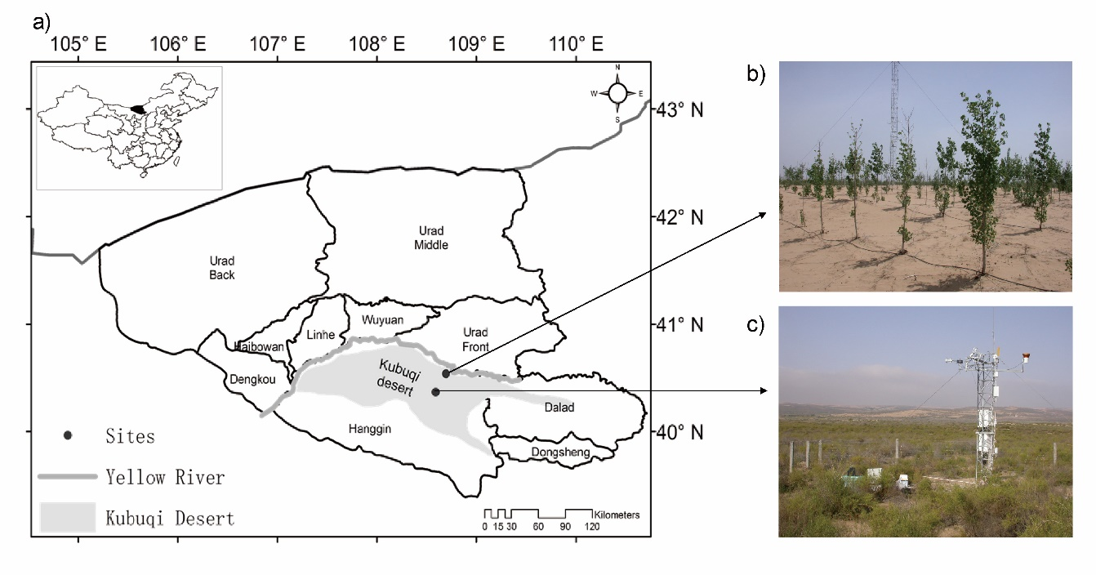
Figure 1. Locations and pictures of the study sites. The right upper figure (b) is the poplar plantation and the right lower photo (c) is the native shrubland. The photos were taken in 2006.

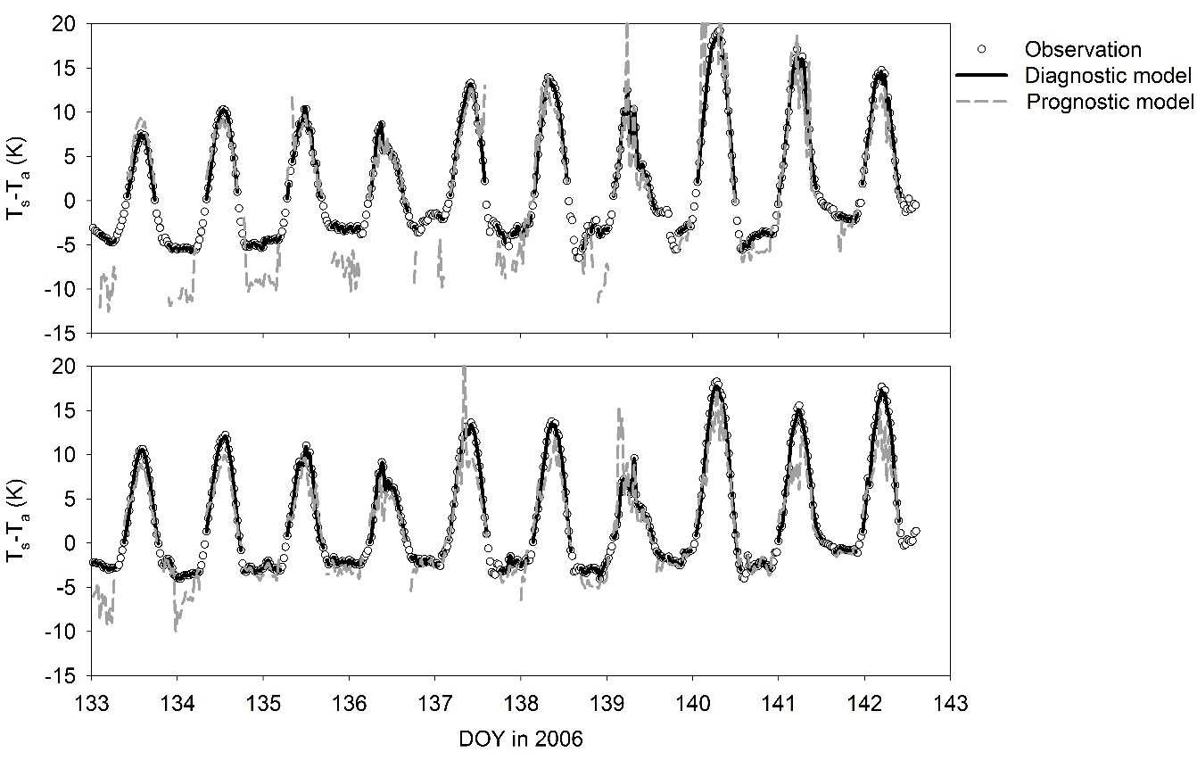
Figure 2. Differences between surface temperature and air temperature at forest site (a) and shrub site (b) in the spring. Dot represents the observations, black solid line represents result of diagnostic model and grey dash line represents result of prognostic model. Horizontal axis is day of year (DOY) in 2006. Each data point represents one half-hourly observation.

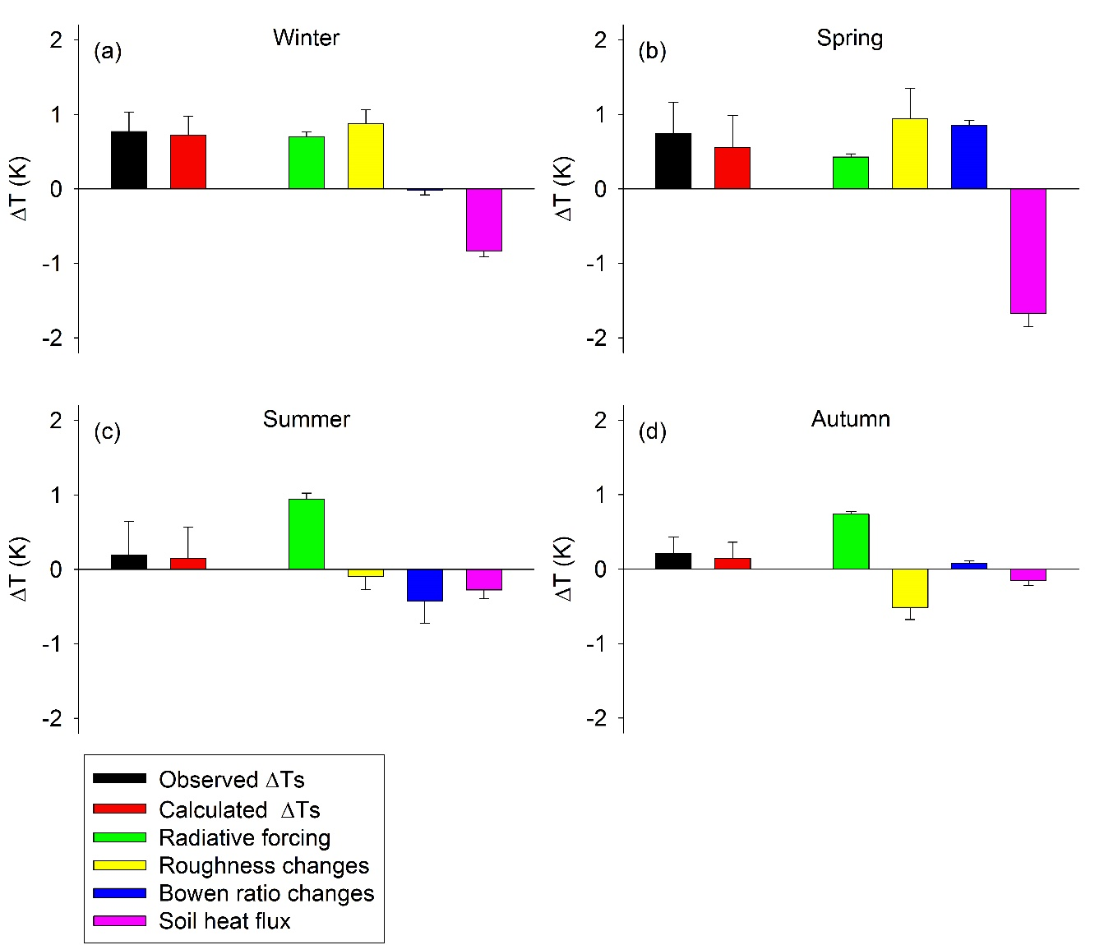
Figure 3. Partition of the daytime biophysical effect in different seasons according to the IBPM theory. Error bars are given as 1SE. Black bars denote observed ΔT_{s}, red bars denote the ΔT_{s} calculated by the IBPM theory, green bars denote radiative forcing, yellow bars denote energy distribution associated with changes in roughness, blue bars denote energy distribution associated with changes in Bowen ratio and pink bars denote the soil heat flux changes. The ΔT_{s} is the temperature of the open shrubland minus the temperature of the plantation forest (here and hereafter).

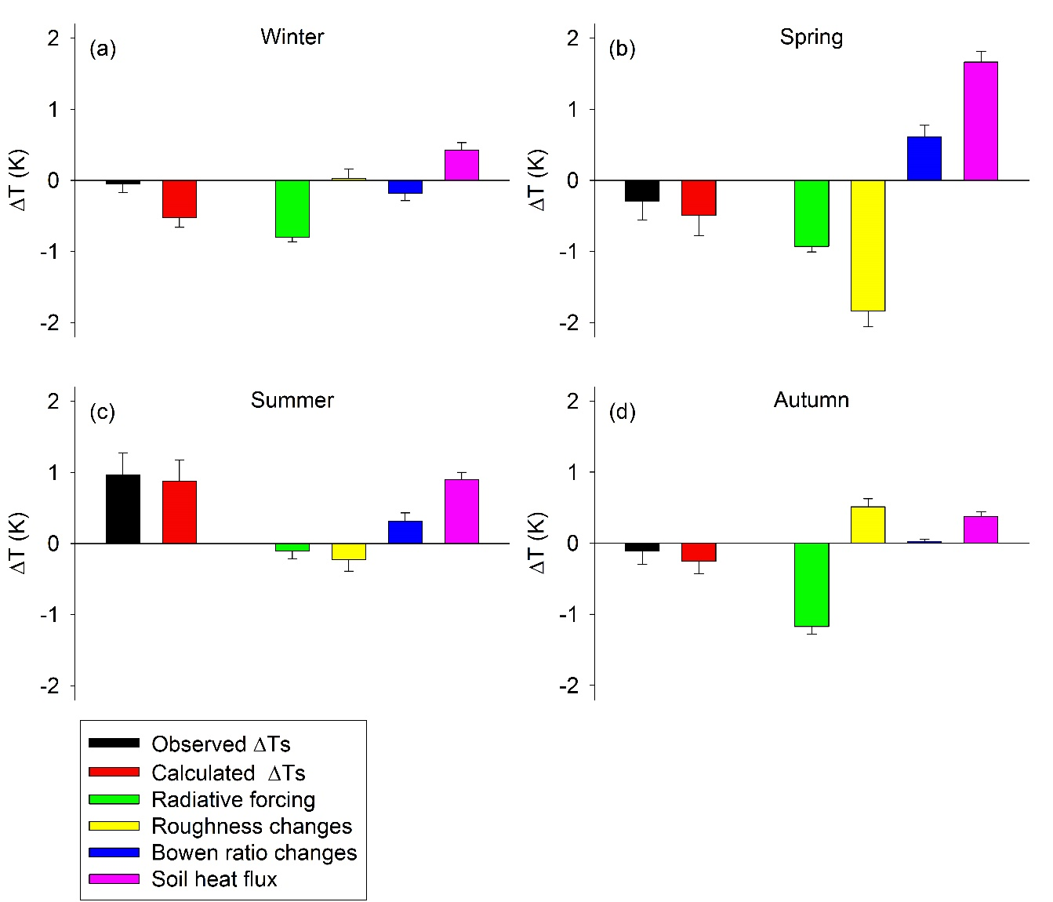
Figure 4. Same as Figure 3 except for nighttime.

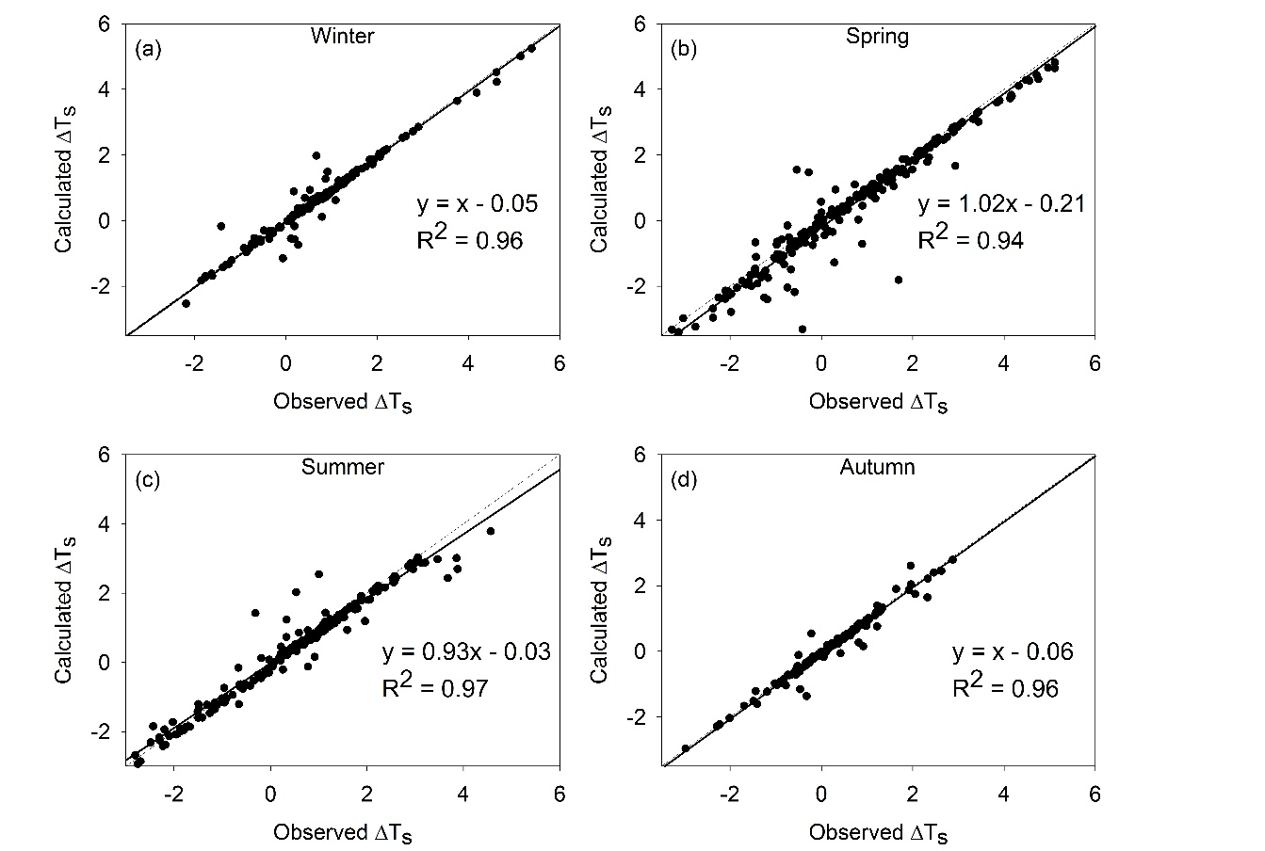
Figure 5. The relationship between half-hour calculated ΔT_{s} and observed ΔT_{s} in different seasons for daytime. Results are based on diagnostic application of the IBPM theory. The regression equations and determination coefficients (R²) were calculated with the geometric mean regression method. The dash lines represent the 1:1 line and the solid lines represent the regression results.

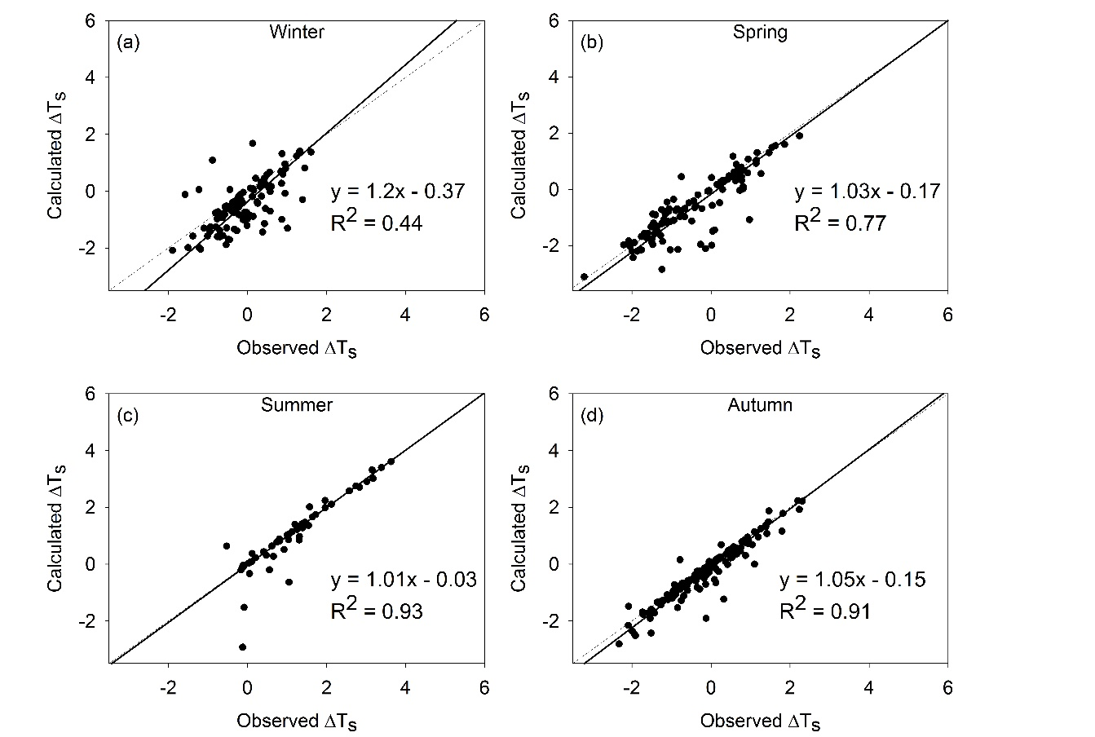
Figure 6. As in Figure 5 except for nighttime.

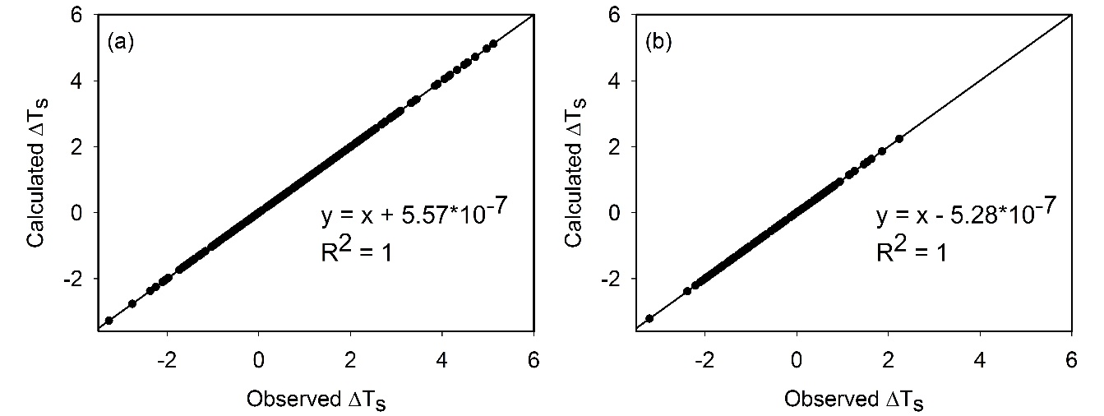
Figure 7. Relationship between half-hour calculated ΔT_{s} and observed ΔT_{s} for spring daytime (a) and spring nighttime periods (b). Results are based on the DTM theory. The regression equations and determination coefficients (R²) were calculated with the geometric mean regression method. The dash lines represent the 1:1 line and the solid lines represent the regression results.

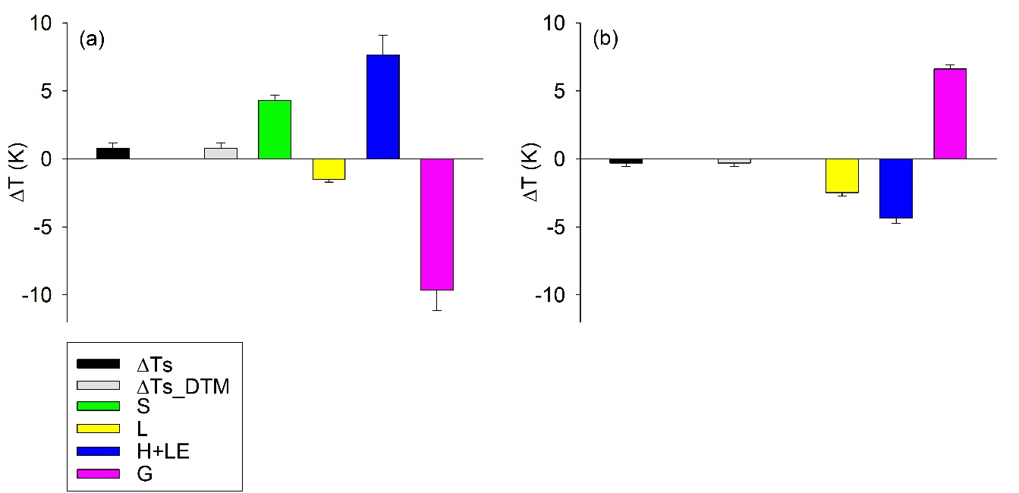
Figure 8. Partition of the biophysical effects in the spring according to the DTM theory in daytime (a) and nighttime (b). Error bars are given as 1SE. Black bars denote observed ΔT_{s}, grey bars denote the ΔT_{s} calculated by the DTM theory, green bars denote shortwave radiative forcing, yellow bars denote incoming longwave radiation changes, blue bars denote sensible heat and latent heat changes, and pink bars denote the soil heat flux changes.

