Supplementary information

Table S1. Summary statistics of the relationship between wintertime CO₂ flux (F_{c,a}, umol m⁻² s⁻¹) and sensible heat (H, W m⁻²) and meteorological conditions at the 64 eddy flux sites.
Site ID | Slope | R² | Air temperature  (℃) | Absolute humidity  (g m⁻³) | Equipment | Vegetation type | Reference
CA-Qcu | −0.003 | 0.23 | −15.47 |  | LI-7500+CSAT3 | ENF | Giasson(2006)
CA-SF1 | −0.017 | 0.68 | −14.99 | 1.76 | LI-7500+CSAT3 | ENF | Amiro (2010)
CA-SF2 | −0.011 | 0.73 | −16.82 | 1.44 | LI-7500+CSAT3 | ENF | Amiro (2010)
CA-SF3 | −0.014 | 0.85 | −14.39 | 1.71 | LI-7500+CSAT3 | OSH | Amiro (2010)
CA-TP1 | 0.0002 | 0.09 | −6.51 |  | LI-7500+CSAT3 | ENF | Peichl (2010)
CN-Arou | −0.005 | 0.86 | −12.74 | 3.23 | LI-7500+CSAT3 | GRA | Liu et al. (2011)
CN-Cha | −0.004 | 0.92 | −12.57 | 1.27 | LI-7500+CSAT3 | ENF | Yu et al. (2006b)
CN-Cng | −0.008 | 0.98 | −13.48 | 1.04 | LI-7500+CSAT3 | GRA | Yu et al. (2006b)
CN-Dan | −0.002 | 0.95 | −8.41 | 1.02 | LI-7500+CSAT3 | GRA | Yu et al. (2006b)
CN-Du2 | 0.001 | 0.70 | −14.21 | 1.16 | LI-7500+CSAT3 | GRA | Zhang et al. (2007)
CN-Gebi | −0.007 | 0.90 | −6.34 | 6.46 | LI-7500+CSAT3 | BAR | Liu et al. (2011)
CN-Ha2 | −0.005 | 0.84 | −13.09 | 0.97 | LI-7500+CSAT3 | OSH | Zhang et al. (2016)
CN-HaM | −0.001 | 0.26 | −13.68 | 1.04 | LI-7500+CSAT3 | GRA | Zhang et al. (2016)
CN-Huazhaizi | −0.003 | 0.84 | −10.39 |  | LI-7500+CSAT3 | ENF | Liu et al. (2011)
CN-Hunhelin | −0.014 | 0.95 | −7.73 | 4.25 | LI-7500+CSAT3 | ENF | Liu et al. (2011)
CN-Huyanlin | −0.011 | 0.94 | −8.00 | 0.93 | LI-7500+CSAT3 | DBF | Liu et al. (2011)
CN-Kub_f | −0.010 | 0.94 | −8.41 | 1.47 | LI-7500+CSAT3 | DBF | This study
CN-Kub_s | −0.014 | 0.98 | −8.45 | 1.43 | LI-7500+CSAT3 | OSH | This study
CN-Shenshawo | −0.015 | 0.70 | −7.21 | 0.19 | LI-7500+CSAT3 | BAR | Liu et al. (2011)
CN-Sw2 | 0.008 | 0.74 | −17.57 | 0.97 | LI-7500+CSAT3 | GRA | Shao et al. (2013)
CN-Xilinguole | −0.002 | 0.11 | −13.15 |  | LI-7500+CSAT3 | GRA | Yu et al. (2006b)
CN-Yucheng | −0.015 | 0.73 | −3.30 |  | LI-7500+CSAT3 | CRO | Yu et al. (2006b)
DE-SfN | −0.018 | 0.77 | −2.89 | 3.88 | LI-7500+CSAT3 | WET | Hommeltenberg et al. (2014)
DE-RuS | −0.037 | 0.94 | −2.05 |  | LI-7500+CSAT3 | CRO | Schmidt et al. (2012)
IT-CA3 | −0.003 | 0.65 | −1.39 | 3.34 | LI-7500+CSAT3 | DBF | Stojanov et al. (2013)
IT-Noe | −0.007 | 0.86 | −1.15 | 3.94 | LI-7500+CSAT3 | OSH | Marras et al. (2011)
IT-Tor | −0.010 | 0.93 | −5.64 | 2.11 | LI-7500+CSAT3 | GRA | Migliavacca et al. (2011)
US-Bn2 | 0.0004 | 0.02 | −11.62 | 1.49 | LI-7500+CSAT3 | DBF | Liu et al. (2005)
US-Bn3 | −0.004 | 0.40 | −11.12 | 1.49 | LI-7500+CSAT3 | OSH | Liu et al. (2005)
US-Br1 | −0.008 | 0.24 | −9.50 | 2.24 | LI-7500+CSAT3 | CRO | Gilmanov et al. (2014)
US-Br3 | −0.004 | 0.38 | −9.41 | 2.23 | LI-7500+CSAT3 | CRO | Gilmanov et al. (2014)
US-CRT | 0.005 | 0.58 | −4.67 | 2.95 | LI-7500+CSAT3 | CRO | Chu et al. (2014)
US-ICh | 0.011 | 0.76 | −13.43 |  | LI-7500+CSAT3 | OSH | Euskirchen et al. (2012)
US-ICs | −0.008 | 0.82 | −14.53 |  | LI-7500+CSAT3 | WET | Euskirchen et al. (2012)
US-KUT | −0.005 | 0.64 | −11.22 | 2.99 | LI-7500+CSAT3 | GRA | Hiller et al. (2011)
US-Oho | −0.010 | 0.82 | −5.63 | 3.78 | LI-7500+CSAT3 | DBF | Noormets et al. (2008)
US-Wi2 | −0.012 | 0.49 | −7.04 | 3.01 | LI-7500+CSAT3 | ENF | Desai et al. (2008)
US-Wi3 | 0.003 | 0.02 | −7.30 | 3.51 | LI-7500+CSAT3 | DBF | Desai et al. (2008)
US-Wi4 | 0.001 | 0.01 | −4.80 | 3.64 | LI-7500+CSAT3 | ENF | Desai et al. (2008)
US-Wi5 | −0.051 | 0.34 | −5.39 | 3.42 | LI-7500+CSAT3 | ENF | Desai et al. (2008)
US-Wi9 | 0.013 | 0.68 | −7.48 | 3.93 | LI-7500+CSAT3 | ENF | Desai et al. (2008)
JP-SMF | −0.010 | 0.83 | −1.37 | 3.13 | LI-7500+DAT540 | ENF | Saigusa et al. (2010)
AT-Neu | −0.030 | 0.71 | −4.94 | 2.82 | LI-7500+Gill | GRA | Haslwanter et al. (2009)
AU-Tum | −0.023 | 0.41 | −1.40 |  | LI-7500+Gill | ENF | Van Gorsel et al. (2007)
CH-Cha | −0.014 | 0.38 | −3.36 | 3.59 | LI-7500+Gill | GRA | Zeeman et al. (2010)
CH-Fru | −0.007 | 0.64 | −4.41 | 3.35 | LI-7500+Gill | GRA | Zeeman et al. (2010)
FR-Fon | −0.009 | 0.81 | −2.34 |  | LI-7500+Gill | DBF | Delpierre et al. (2015)
IT-CA1 | 0.013 | 0.72 | −1.38 | 3.38 | LI-7500+Gill | DBF | Stojanov et al. (2013)
IT-La2 | 0.000 | 0.00 | −3.22 | 2.44 | LI-7500+Gill | ENF | Cava et al. (2008)
IT-Lav | −0.010 | 0.85 | −3.47 | 2.79 | LI-7500+Gill | ENF | Cava et al. (2008)
RU-Cok | −0.002 | 0.02 | −33.29 | -0.15 | LI-7500+Gill | OSH | Parmentier et al. (2011)
NL-Hor | −0.010 | 0.92 | −1.84 |  | LI-7500+Gill | ENF | Hendriks et al. (2008)
RU-Ha1 | −0.009 | 0.98 | −17.11 | 1.04 | LI-7500+Gill | GRA | Marchesini et al. (2007)
US-Ne1 | −0.003 | 0.23 | −7.09 | 2.52 | LI-7500+Gill | CRO | Suyker et al. (2004)
US-Ne2 | −0.002 | 0.22 | −7.50 | 2.52 | LI-7500+Gill | CRO | Suyker et al. (2004)
US-Ne3 | −0.004 | 0.24 | −7.09 | 2.46 | LI-7500+Gill | CRO | Suyker et al. (2004)
US-Sdh | 0.007 | 0.71 | −5.38 | 4.69 | LI-7500+Gill | GRA | Billesbach and Arkebauer (2012)
CN-Daman | −0.009 | 0.69 | −7.89 | 6.02 | LI-7500A+CSAT3 | CRO | Liu et al. (2011)
CN-Nongtian | −0.013 | 0.94 | −8.02 |  | LI-7500A+CSAT3 | CRO | Liu et al. (2011)
CN-Shidi | −0.017 | 0.90 | −6.30 | 9.02 | LI-7500A+CSAT3 | WET | Liu et al. (2011)
CN-Sidaoqiao | −0.003 | 0.50 | −7.52 | 5.61 | LI-7500A+CSAT3 | DBF | Liu et al. (2011)
IT-CA2 | −0.014 | 0.77 | −1.33 | 3.39 | LI-7500A+CSAT3 | CRO | Stojanov et al. (2013)
CN-Tarim | −0.017 | 0.75 | −7.14 | 4.04 | LI-7500A+Gill | DBF | Wang et al. (2016)
CN-Tarim2 | −0.019 | 0.94 | −8.08 | 2.20 | IRGASON+Gill | DBF | Wang et al. (2016)

Table S2. Detail information about the open-path eddy covariance sites used in this study. MAP: mean annual precipitation; MAT: mean annual temperature.
Site ID | Site name | MAP  (mm) | MAT  (°C) | Latitude (degrees) | Longitude  (degrees) | Years of data
CA-Qcu | Quebec - Eastern Boreal, Black Spruce/Jack Pine Cutover | 950 | 0.13 | 49.2671 | −74.0365 | 2001-2010
CA-SF1 | Saskatchewan - Western Boreal, forest burned in 1977 | 470 | 0.4 | 54.485 | −105.818 | 2003-3006
CA-SF2 | Saskatchewan - Western Boreal, forest burned in 1989 | 470 | 0.4 | 54.2539 | −105.878 | 2001-2006
CA-SF3 | Saskatchewan - Western Boreal, forest burned in 1998 | 470 | 0.4 | 54.0916 | −106.005 | 2001-2006
CA-TP1 | Ontario - Turkey Point 2002 Plantation White Pine | 1036 | 8 | 42.6609 | −80.5595 | 2002-2015
CN-Aro | Arou |  |  | 38.0473 | 100.4643 | 2008-2009
CN-Cha | Changbaishan |  |  | 42.4025 | 128.0958 | 2003-2005
CN-Cng | Changling |  |  | 44.5934 | 123.5092 | 2010
CN-Dan | Dangxiong |  |  | 30.4978 | 91.0664 | 2004-2005
CN-Du2 | Duolun grassland |  |  | 42.0467 | 116.2836 | 2007-2008
CN-Gebi | Heihe Gebi |  |  | 42.0012 | 101.1374 | 2014
CN-Ha2 | Haibei shrubland |  |  | 37.6086 | 101.3269 | 2003-2005
CN-HaM | Haibei Alpine |  |  | 37.3700 | 101.1800 | 2002-2004
CN-Huazhaizi | Heihe Huazhaizi |  |  | 38.7652 | 100.3186 | 2014
CN-Hunhelin | Heihe mixed forest |  |  | 41.9903 | 101.1335 | 2014
CN-Huyanlin | Heihe Populus euphratica |  |  | 41.9928 | 101.1236 | 2014
CN-Kub_f | Kubuqi Populus |  |  | 40.5383 | 108.6936 | 2006-2008
CN-Kub_s. | Kubuqi shrubland |  |  | 40.3808 | 108.5486 | 2006-2008
CN-Shenshawo | Heihe Shenshawo |  |  | 38.78917 | 100.4933 | 2014
CN-Sw2 | Siziwang Grazed |  |  | 41.7902 | 111.8971 | 2010-2012
CN-Xilinguole | Xilinguole |  |  | 44.1333 | 116.3000 | 2004-2005
CN-Yucheng | Yucheng |  |  | 36.9583 | 116.6406 | 2004-2005
DE-RuS | Selhausen Juelich | 700 | 10 | 50.86591 | 6.447169 | 2011-2014
DE-SfN | Schechenfilz Nord | 1127 | 8.6 | 47.80639 | 11.3275 | 2012-2014
IT-CA3 | Castel d'Asso 3 | 766 | 14 | 42.38 | 12.0222 | 2011-2013
IT-Noe | Arca di Noe - Le Prigionette | 588 | 15.9 | 40.60613 | 8.15146 | 2004-2014
IT-Tor | Torgnon | 2.9 | CO2−E/C | 45.84444 | 7.578055 | 2008-2013
US-Bn2 | Bonanza Creek, 1987 Burn site near Delta Junction |  |  | 63.9198 | −145.378 | 2002-2004
US-Bn3 | Bonanza Creek, 1999 Burn site near Delta Junction |  |  | 63.9227 | −145.744 | 2002-2004
US-Br1 | Brooks Field Site 10- Ames | 842 | 8.95 | 41.6915 | −93.6914 | 2005-2011
US-Br3 | Brooks Field Site 11- Ames | 847 | 8.9 | 41.9747 | −93.6936 | 2005-2011
US-CRT | Curtice Walter-Berger cropland | 849 | 10.1 | 41.6285 | −83.3471 | 2011-2013
US-ICh | Imnavait Creek Watershed Heath Tundra | 318 | −7.4 | 68.6068 | −149.296 | 2007-2011
US-ICs | Imnavait Creek Watershed Wet Sedge Tundra | 318 | −7.4 | 68.6058 | −149.311 | 2007-2011
US-KUT | KUOM Turfgrass Field | 777 | 7.9 | 44.995 | −93.1863 | 2005-2009
US-Oho | Oak Openings | 849 | 10.1 | 41.5545 | −83.8438 | 2004-2013
US-Wi2 | Intermediate red pine (IRP) |  |  | 46.6869 | −91.1528 | 2003
US-Wi3 | Mature hardwood (MHW) |  |  | 46.6347 | −91.0987 | 2002-2004
US-Wi4 | Mature red pine (MRP) |  |  | 46.7393 | −91.1663 | 2002-2005
US-Wi5 | Mixed young jack pine (MYJP) |  |  | 46.6531 | −91.0858 | 2004
US-Wi9 | Young Jack pine (YJP) |  |  | 46.6188 | −91.0814 | 2004-2005
JP-SMF | Seto |  |  | 35.2617 | 137.0788 | 2002-2006
AT-Neu | Neustift | 852 | 6.3 | 47.11667 | 11.3175 | 2003
AU-Tum | Tumbarumba |  |  | −35.6566 | 148.1517 | 2001-2014
CH-Cha | Chamau | 1136 | 9.5 | 47.21022 | 8.410444 | 2006-2012
CH-Fru | Früebüel | 1651 | 7.2 | 47.11583 | 8.537778 | 2006-2012
FR-Fon | Fontainebleau-Barbeau | 720 | 10.2 | 48.4764 | 2.780142 | 2005-2014
IT-CA1 | Castel d'Asso1 | 766 | 14 | 42.38041 | 12.02656 | 2011-2014
IT-La2 | Lavarone2 | 1150 | 7.2 | 45.9542 | 11.2853 | 2000-2002
IT-Lav | Lavarone | 1291 | 7.8 | 45.9562 | 11.28132 | 2003-2014
NL-Hor | Horstermeer | 800 | 10 | 52.24035 | 5.071301 | 2004-2011
RU-Cok | Chokurdakh | 232 | −14.3 | 70.82914 | 147.4943 | 2003-2013
RU-Ha1 | Hakasia steppe | 360 | 0.5 | 54.7252 | 90.0022 | 2002-2004
US-Ne1 | Mead - irrigated continuous maize site | 790 | 10.07 | 41.1651 | −96.4766 | 2001-2013
US-Ne2 | Mead - irrigated maize-soybean rotation site | 789 | 10.08 | 41.1649 | −96.4701 | 2001-2013
US-Ne3 | Mead - rainfed maize-soybean rotation site | 784 | 10.11 | 41.1797 | −96.4397 | 2001-2013
US-Sdh | Nebraska SandHills Dry Valley |  |  | 42.0693 | −101.407 | 2004-2009
CN-Daman | Daman |  |  | 38.8555 | 100.3722 | 2014
CN-Nongtian | Heihe cropland |  |  | 42.0048 | 101.1338 | 2014
CN-Shidi | Heihe wetland |  |  | 38.9751 | 100.4464 | 2014
CN-Sidaoqiao | Heihe Sidaoqiao |  |  | 42.0012 | 101.1374 | 2014
IT-CA2 | Castel d'Asso2 | 766 | 14 | 42.37722 | 12.02604 | 2011-2013
CN-Tarim | Tarim Populus euphratica |  |  | 40.4331 | 88.0261 | 2013
CN-Tarim2 | Tarim Populus euphratica |  |  | 40.4331 | 88.0261 | 2013

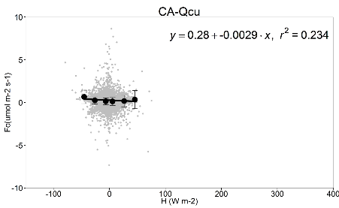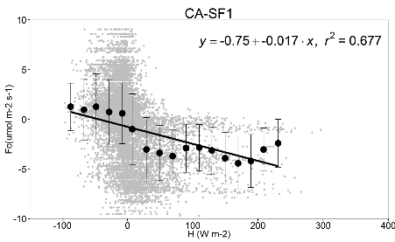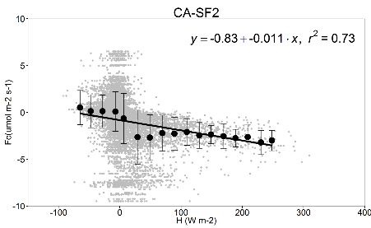
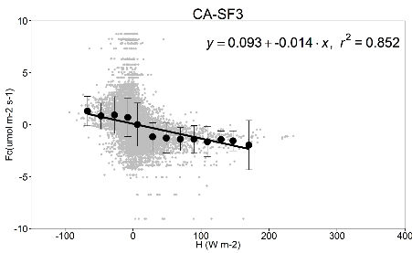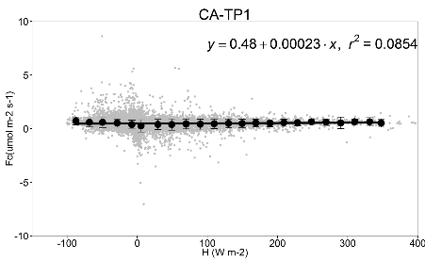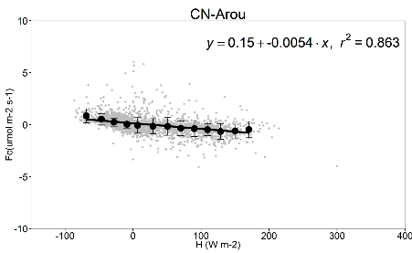
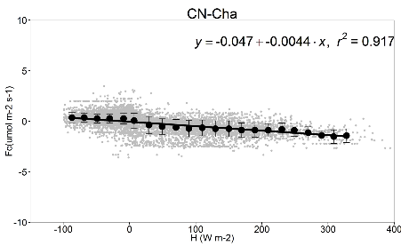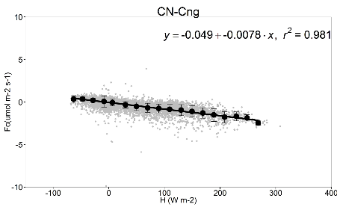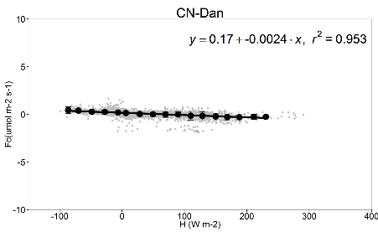
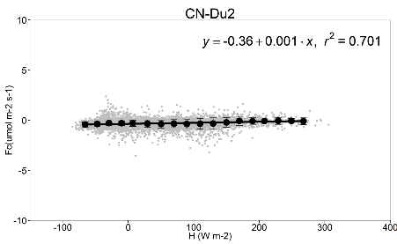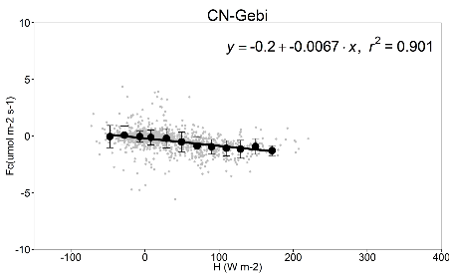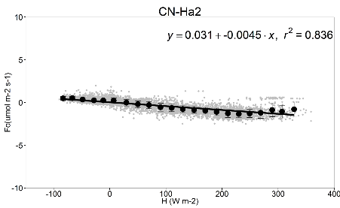
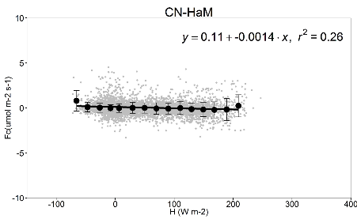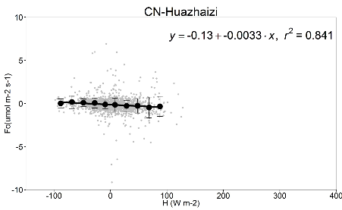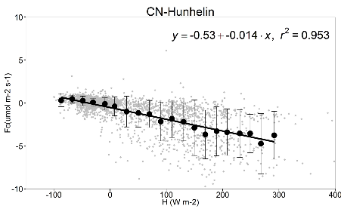
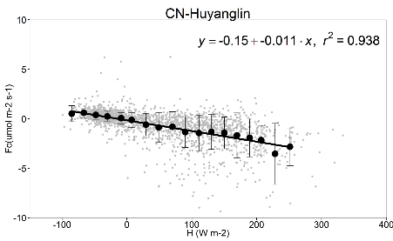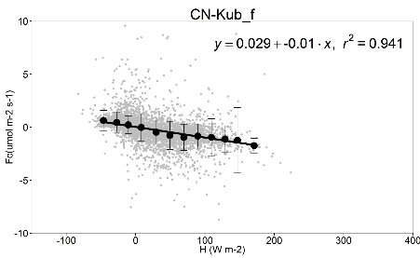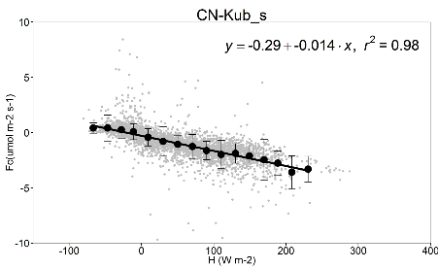
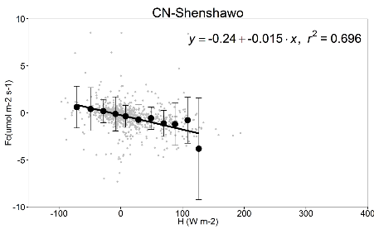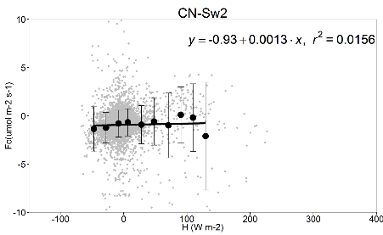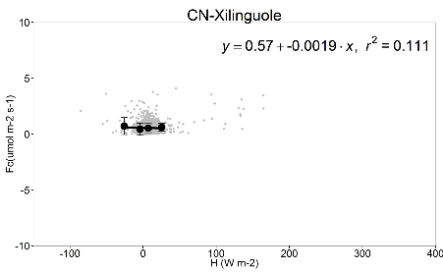

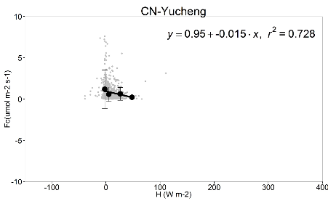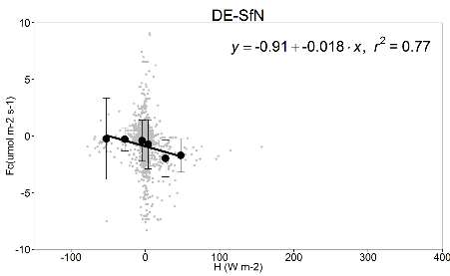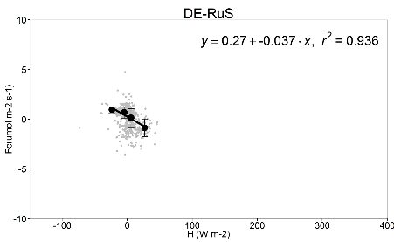
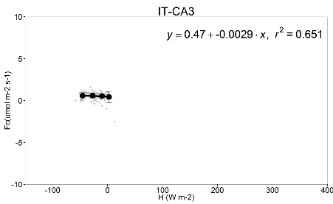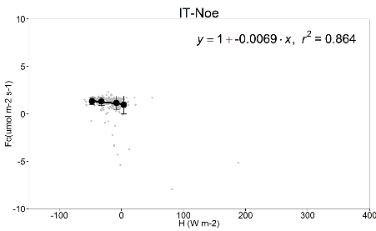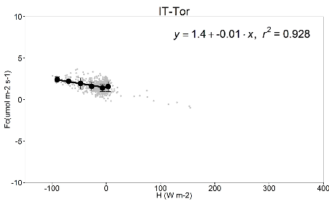
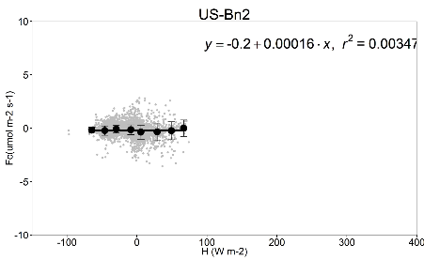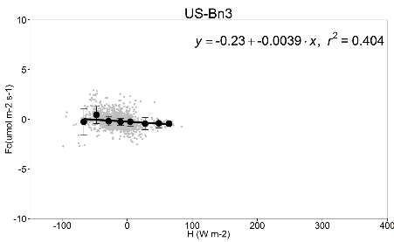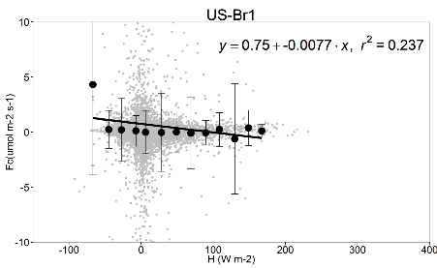
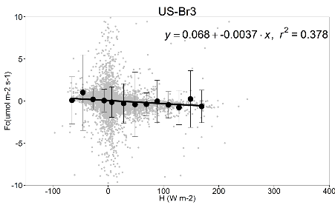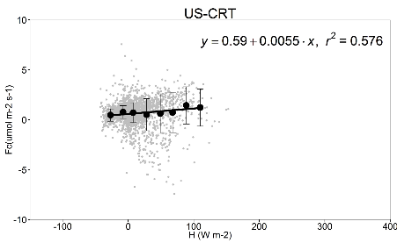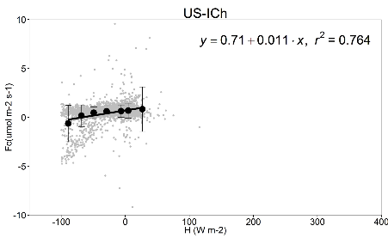
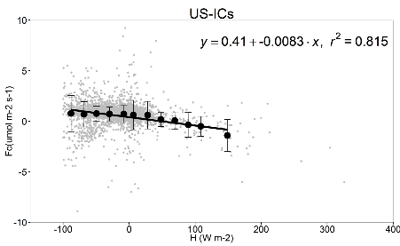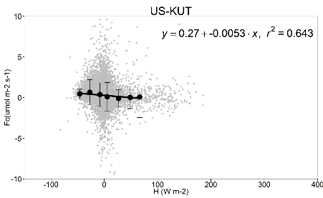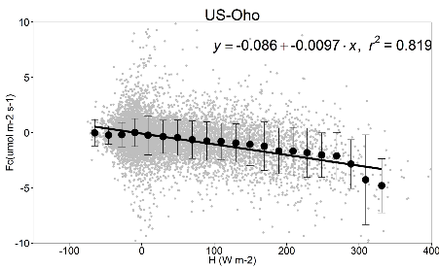
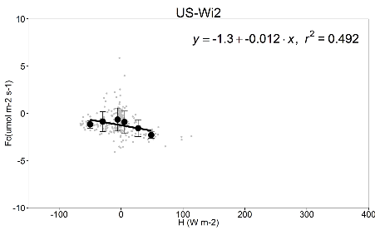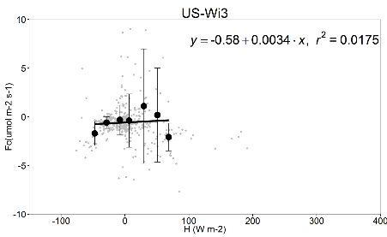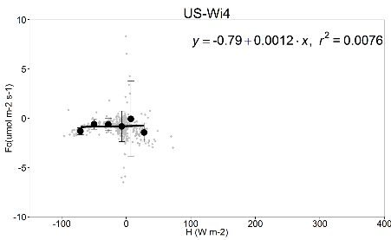
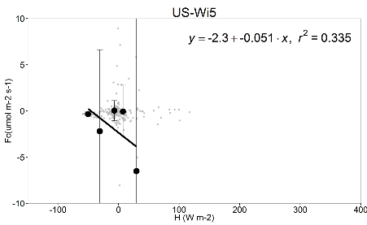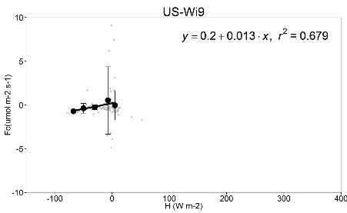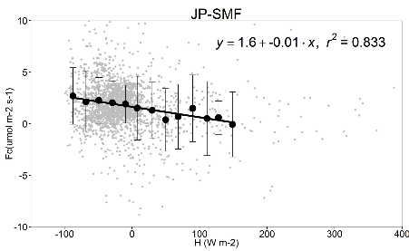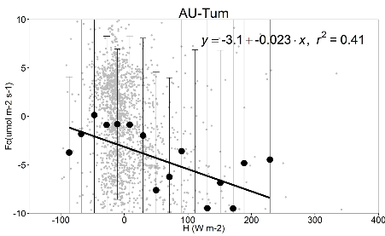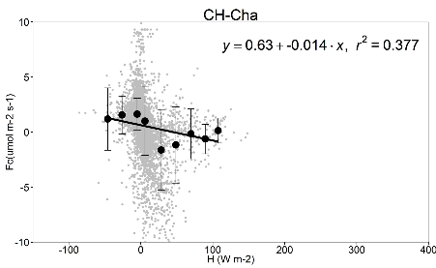
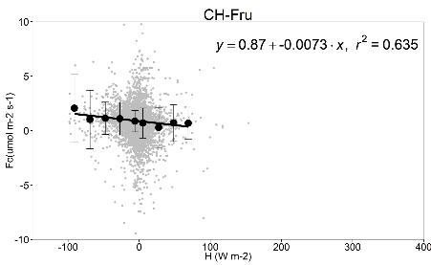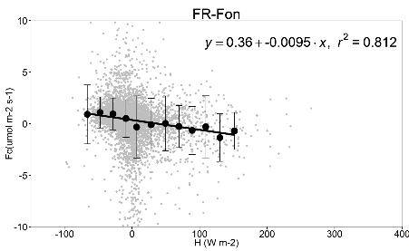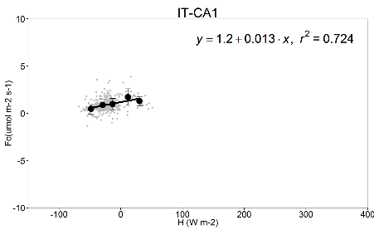
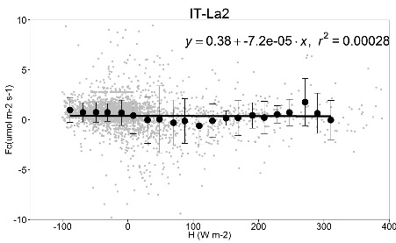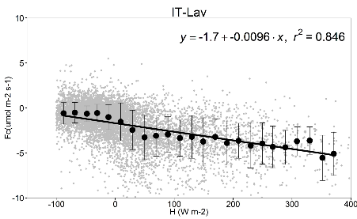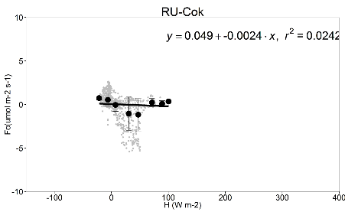
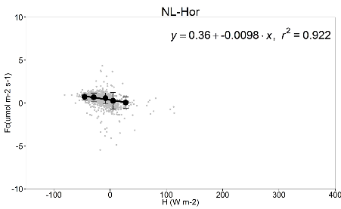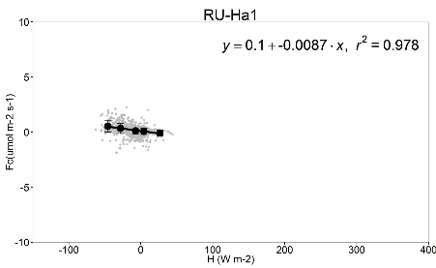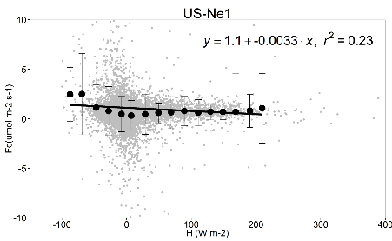
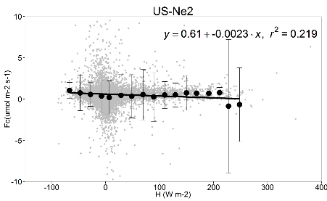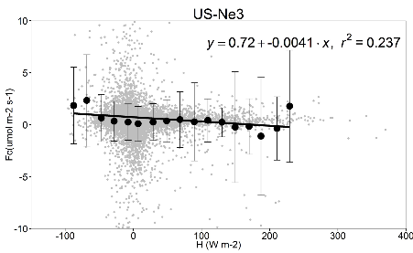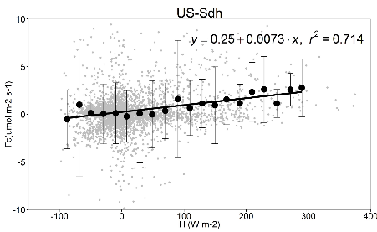
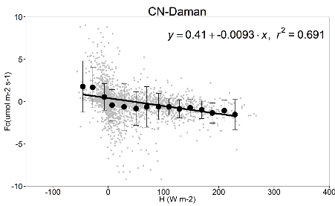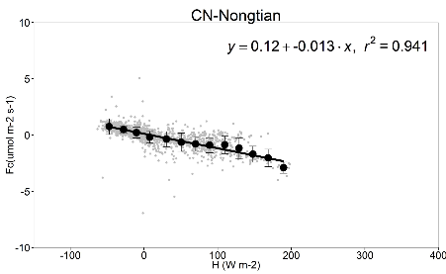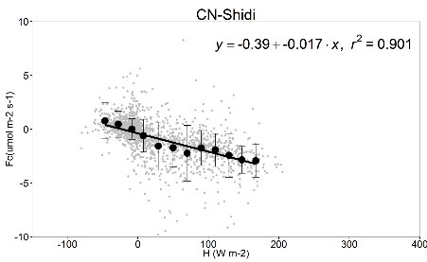
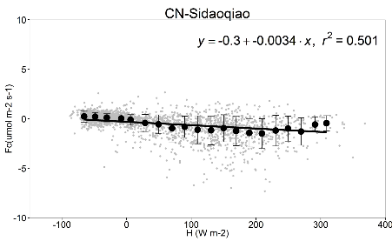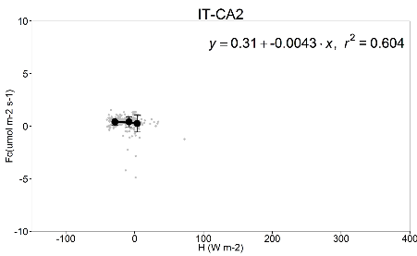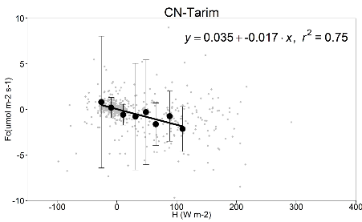
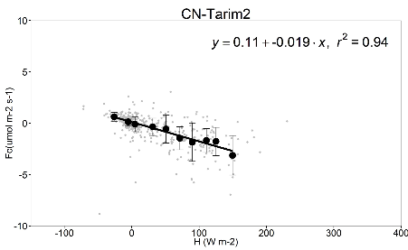
Figure S1. Relationship between wintertime CO₂ flux (F_{c}) and sensible heat (H). Grey dots represent half-hourly data, and black dots and error bars represent bin-average values and standard deviations.

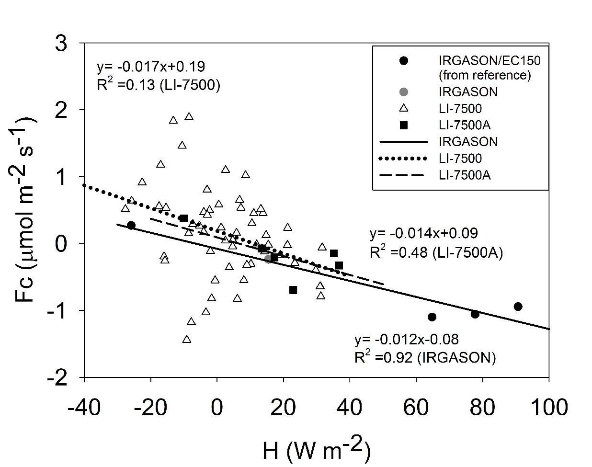
Figure S2. The site-mean CO₂ flux versus the site mean sensible heat flux. Different symbols represent different analyzer types.

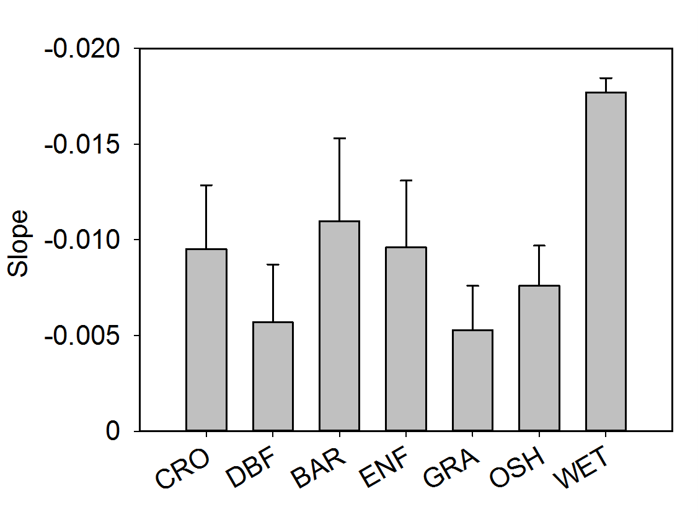
Figure S3. Comparison of the regression slope parameter b (μmol m⁻² s⁻¹ per W m⁻²) by vegetation type. Error bars are ± 1 standard error. CRO: Croplands (number of sites 11); DBF: Deciduous Broadleaf Forests (10); BAR: Barrens (2); ENF: Evergreen Needleleaf Forests (16); GRA: Grasslands (14); OSH: Open Shrublands (6); WET: Permanent Wetlands (2).

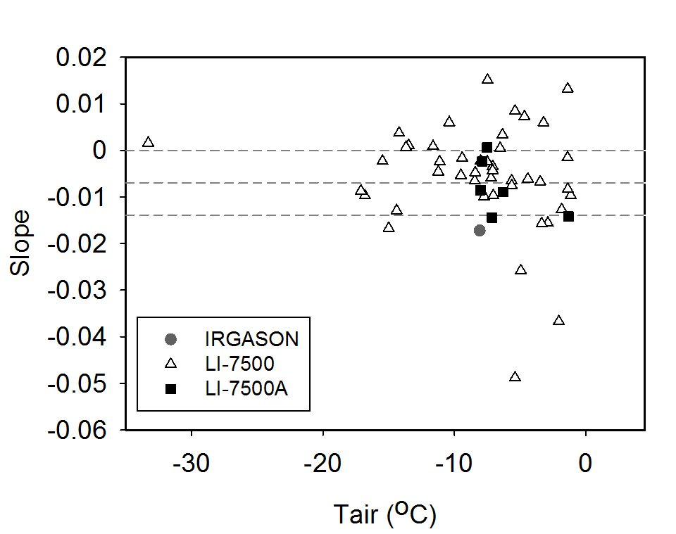
Figure S4. The regression slope parameter b (μmol m⁻² s⁻¹ per W m⁻²) with the effect of ρ_{c} biases excluded versus air temperature.

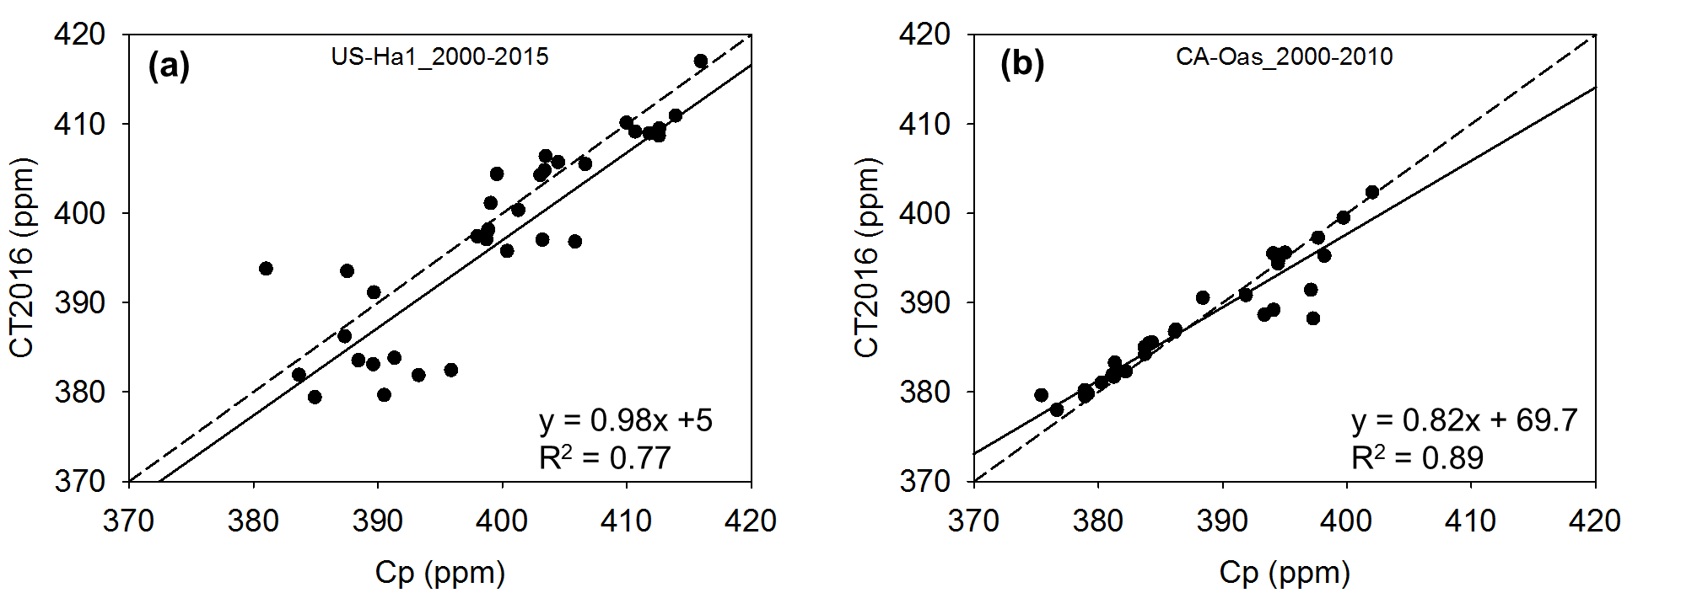
Figure S5. Comparison of the CarbonTracker surface monthly (December, January, February) mean CO₂ mole fraction against the monthly CO₂ mole fraction (in ppm) measured by close-path EC analyzers (Cp) at Harvard Forest, U.S. (panel a) and at Old Aspen, Canada (panel b). The periods of comparison are 2000-2015 for Harvard Forest and 2000-2010 for Old Aspen.
References
Amiro, B., 2010: Estimating annual carbon dioxide eddy fluxes using open-path analysers for cold forest sites. Agricultural and Forest Meteorology, 150, 1366-1372.
Billesbach, D. P., and T. J. Arkebauer, 2012: First long-term, direct measurements of evapotranspiration and surface water balance in the Nebraska SandHills. Agricultural and Forest Meteorology, 156, 104-110.
Cava, D., G. G. Katul, A. M. Sempreviva, U. Giostra, and A. Scrimieri, 2008: On the Anomalous Behaviour of Scalar Flux–Variance Similarity Functions Within the Canopy Sub-layer of a Dense Alpine Forest. Boundary-Layer Meteorology, 128, 33.
Chu, H., J. Chen, J. F. Gottgens, Z. Ouyang, R. John, K. Czajkowski, and R. Becker, 2014: Net ecosystem methane and carbon dioxide exchanges in a Lake Erie coastal marsh and a nearby cropland. J. Geophys. Res., Biogeosci., 119, 722-740.
Delpierre, N., D. Berveiller, E. Granda, and E. Dufrêne, 2015: Wood phenology, not carbon input, controls the interannual variability of wood growth in a temperate oak forest. New Phytol. 210, 459-470
Desai, A. R., and Coauthors, 2008: Influence of vegetation and seasonal forcing on carbon dioxide fluxes across the Upper Midwest, USA: Implications for regional scaling. Agricultural and Forest Meteorology, 148, 288-308.
Euskirchen, E., M. S. Bret-Harte, G. Scott, C. Edgar, and G. R. Shaver, 2012: Seasonal patterns of carbon dioxide and water fluxes in three representative tundra ecosystems in northern Alaska. Ecosphere, 3, 1-19.
Giasson, M. A., C. Coursolle, and H. A. Margolis, 2006: Ecosystem-level CO2 fluxes from a boreal cutover in eastern Canada before and after scarification. Agricultural and Forest Meteorology, 140, 23-40.
Gilmanov, T. G., and Coauthors, 2014: Productivity and Carbon Dioxide Exchange of Leguminous Crops: Estimates from Flux Tower Measurements. Agronomy Journal, 106, 545-559.
Haslwanter, A., A. Hammerle, and G. Wohlfahrt, 2009: Open- vs. closed-path eddy covariance measurements of the net ecosystem carbon dioxide and water vapour exchange: a long-term perspective. Agricultural and forest meteorology, 149, 291-302.
Hendriks, D., A. Dolman, M. Van Der Molen, and J. v. Huissteden, 2008: A compact and stable eddy covariance set-up for methane measurements using off-axis integrated cavity output spectroscopy. Atmospheric chemistry and Physics, 8, 431-443.
Hiller, R. V., J. P. McFadden, and N. Kljun, 2011: Interpreting CO2 Fluxes Over a Suburban Lawn: The Influence of Traffic Emissions. Boundary-Layer Meteorology, 138, 215-230.
Hommeltenberg, J., H. P. Schmid, M. Drösler, and P. Werle, 2014: Can a bog drained for forestry be a stronger carbon sink than a natural bog forest? Biogeosciences, 11, 3477-3493.
Liu, H., J. T. Randerson, J. Lindfors, and F. S. Chapin, 2005: Changes in the surface energy budget after fire in boreal ecosystems of interior Alaska: An annual perspective. Journal of Geophysical Research: Atmospheres, 110.
Liu, S., Z. Xu, W. Wang, Z. Jia, M. Zhu, J. Bai, and J. Wang, 2011: A comparison of eddy-covariance and large aperture scintillometer measurements with respect to the energy balance closure problem. Hydrology and Earth System Sciences, 15, 1291-1306.
Marchesini, L. B., D. Papale, M. Reichstein, N. Vuichard, N. Tchebakova, and R. Valentini, 2007: Carbon balance assessment of a natural steppe of southern Siberia by multiple constraint approach. Biogeosciences Discussions, 4, 165-208.
Marras, S., R. D. Pyles, C. Sirca, K. T. Paw U, R. L. Snyder, P. Duce, and D. Spano, 2011: Evaluation of the Advanced Canopy–Atmosphere–Soil Algorithm (ACASA) model performance over Mediterranean maquis ecosystem. Agricultural and Forest Meteorology, 151, 730-745.
Migliavacca, M., and Coauthors, 2011: Using digital repeat photography and eddy covariance data to model grassland phenology and photosynthetic CO2 uptake. Agricultural and Forest Meteorology, 151, 1325-1337.
Noormets, A., S. G. McNulty, J. L. DeForest, G. Sun, Q. Li, and J. Chen, 2008: Drought during canopy development has lasting effect on annual carbon balance in a deciduous temperate forest. New Phytol., 179, 818-828.
Parmentier, F., and Coauthors, 2011: Longer growing seasons do not increase net carbon uptake in the northeastern Siberian tundra. J. Geophys. Res., Biogeosci., 116.
Peichl, M., M. A. Arain, and J. J. Brodeur, 2010: Age effects on carbon fluxes in temperate pine forests. Agricultural and Forest Meteorology, 150, 1090-1101.
Saigusa, N., and Coauthors, 2010: Impact of meteorological anomalies in the 2003 summer on gross primary productivity in East Asia. Biogeosciences, 7, 641-655.
Schmidt, M., T. G. Reichenau, P. Fiener, and K. Schneider, 2012: The carbon budget of a winter wheat field: An eddy covariance analysis of seasonal and inter-annual variability. Agricultural and Forest Meteorology, 165, 114-126.
Shao, C., J. Chen, and L. Li, 2013: Grazing alters the biophysical regulation of carbon fluxes in a desert steppe. Environmental Research Letters, 8, 025012.
Stojanov, R., Z. Žalud, P. Cudlín, A. Farda, O. Urban, and M. Trnka, 2013: Global Change and Resilience. Climate of the Past, 9, 41-56.
Suyker, A. E., S. B. Verma, G. G. Burba, T. J. Arkebauer, D. T. Walters, and K. G. Hubbard, 2004: Growing season carbon dioxide exchange in irrigated and rainfed maize. Agricultural and Forest Meteorology, 124, 1-13.
Van Gorsel, E., R. Leuning, H. A. Cleugh, H. Keith, and T. Suni, 2007: Nocturnal carbon efflux: Reconciliation of eddy covariance and chamber measurements using an alternative to the u*‐threshold filtering technique. Tellus B, 59, 397-403.
Wang, W., and Coauthors, 2016: Performance evaluation of an integrated open-path eddy covariance system in a cold desert environment. Journal of Atmospheric and Oceanic Technology, 33(11), 2385-2399.
Yu, G.R., X.F. Wen, X.M. Sun, B. D. Tanner, X. Lee, and J.Y. Chen, 2006: Overview of ChinaFLUX and evaluation of its eddy covariance measurement. Agricultural and Forest Meteorology, 137, 125-137.
Zeeman, M. J., R. Hiller, A. K. Gilgen, P. Michna, P. Plüss, N. Buchmann, and W. Eugster, 2010: Management and climate impacts on net CO2 fluxes and carbon budgets of three grasslands along an elevational gradient in Switzerland. Agricultural and Forest Meteorology, 150, 519-530.
Zhang, T., and Coauthors, 2016: Ecosystem response more than climate variability drives the inter-annual variability of carbon fluxes in three Chinese grasslands. Agricultural and Forest Meteorology, 225, 48-56.
Zhang, W. L., S. P. Chen, J. Chen, L. Wei, X. G. Han, and G. H. Lin, 2007: Biophysical regulations of carbon fluxes of a steppe and a cultivated cropland in semiarid Inner Mongolia. Agricultural and Forest Meteorology, 146, 216-229.

