Readme_Taihu_Fluxnet_MET_Rad_Tw_2010-2016.doc
(Update July 12, 2017)

0) Fair use policy: Kindly inform the appropriate Principal Investigators of how you are using site data and of any publication plans. If the Principal Investigators feel that they should be acknowledged or offered participation as authors, they will let you know and we assume that an agreement on such matters will be reached prior to publishing and/or use of the data for publication. If your work directly competes with the Principal Investigator's analysis they may ask that they have the opportunity to submit a manuscript before you submit the one that uses their data. In addition, when publishing, please acknowledge the agency that supported the research.

1) Contact info: xuhui.lee@yale.edu, phone 203-432-6271, fax 203-432-5023
wei.xiao@nuist.edu.cn, phone 85-15050575821
wangw@nuist.edu.cn, phone 85-15195915526

2) Data from the Taihu Eddy Flux Network at Lake Taihu, East China. Details of the site and instrumentation are given by Lee et al. 2014, available at http://yncenter.sites.yale.edu/publications
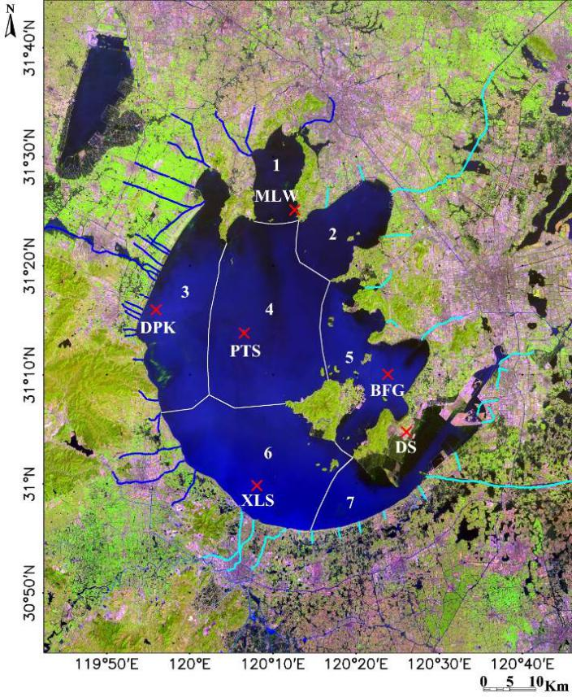
Fig. 1. A Landsat 8 image of Lake Taihu and its surrounding area, taken on 14 Apr 2013. Color composite is 654 red-blue-green (RGB). Red crosses mark locations of the eddy covariance sites. Blue and green lines mark inflow and outflow rivers, respectively. Areas in green are vegetation and areas in purple and brown are cities.
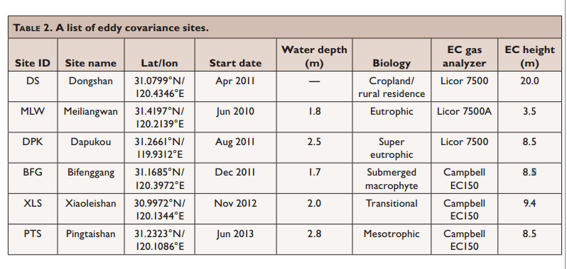

3) The file naming is SiteName_yyyy, where SiteName is the unique site identifier described in above table; yyyy is the sampling year. Each day have 48 records. Missing values and parameters not reported are denoted by -9999.

4) Relevant references:
[1] Lee X, S Liu, W Xiao, W Wang, Z Gao, C Cao, C Hu, Z Hu, S Shen, Y Wang, X Wen, Q Xiao, J Xu, J Yang, M Zhang (2014) The Taihu Eddy Flux Network: an observational program on energy, water, and greenhouse gas fluxes of a large freshwater lake. Bulletin of American Meteorological Society 95: 1583-1594.
[2] Wang W, W Xiao, C Cao, Z Gao, Z Hu, S Liu, S Shen, L Wang, Q Xiao, J Xu, D Yang, X Lee (2014) Temporal and spatial variations in radiation and energy balance across a large freshwater lake in China. Journal of Hydrology 511: 811-824.

5) Content and format of header records:

Sheet SiteName_MET_yyyy: Micrometeorological data
(:,1): TMSTAMP, China Standard Time of day expressed in YYYY/MO/DD HH:MM format (e.g., 2:30 AM = 2:30; 2:30 PM = 14:30). Each half-hourly timestamp indicates the end of the measurement period.
(:,2): DOY, Day of year
(:,3): P, Ambient air pressure, expressed in kPa
(:,4): Ta, Air temperature, expressed in degrees Celsius
(:,5): RH, Relative humidity of air expressed as a percentage
(:,6): U, wind speed, expressed in m s⁻¹

Sheet SiteName_Radiation_yyyy: Radiation components data
(:,1): TMSTAMP, China Standard Time of day expressed in a YYYY/MO/DD HH:MM format (e.g., 2:30 AM = 2:30; 2:30 PM = 14:30). Each half-hourly timestamp indicates the end of the measurement period.
(:,2): DOY, Day of year
(:,3): UR_Ave, Upward shortwave radiation, expressed in W m⁻²
(:,4): DR_Ave, Downward shortwave radiation, expressed in W m⁻²
(:,5): ULR_Ave, Upward longwave radiation, expressed in W m⁻²
(:,6): DLR_Ave, Downward longwave radiation, expressed in W m⁻²

Sheet SiteName_Tw_yyyy: Lake water temperature profile data
(:,1): TMSTAMP, China Standard Time of day expressed in a YYYY/MO/DD HH:MM format (e.g., 2:30 AM = 2:30; 2:30 PM = 14:30). Each half-hourly timestamp indicates the end of the measurement period.
(:,2): DOY, Day of year
(:,3): T_W_20cm_Avg, Water temperature measured at depth 20 cm, expressed in degrees Celsius
(:,4): T_W_50cm_Avg, Water temperature measured at depth 50 cm, expressed in degrees Celsius
(:,5): T_W_100cm_Avg, Water temperature measured at depth 100 cm, expressed in degrees Celsius
(:,6): T_W_150cm_Avg, Water temperature measured at depth 150 cm, expressed in degrees Celsius
(:,7): T_W_200cm_Avg, Temperature measured in lake sediment, expressed in degrees Celsius

